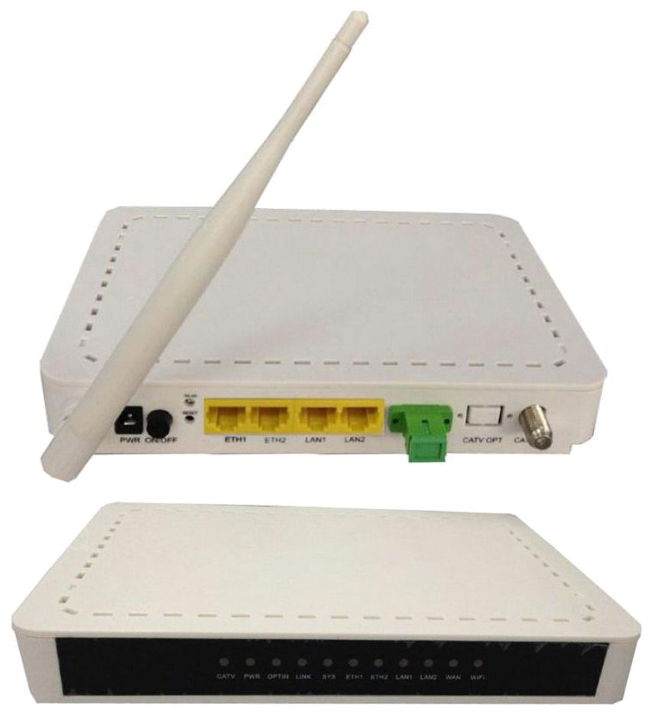
ONU-4FE-RFW ONU Manual
ONU-4FE-RFW ONU
( 4FE+CATV+WIFI)
Brief Views
The ONU is designed mainly for FTTH use and FTTO use as well. It support 1000Base-PX10/PX20
standard with 1:64 maximum optical splitting ratio and 20km distance, and provide 1uplink GE
PON port.
It work together with OLT could realize flexible network structure and maintenance and provide
total FTTx solutions.
It built in CATV Receiver to realize the analog or DVB TV signals transmission.
It adopts single fiber WDM technology with downlink wavelength 1550nm and 1490nm, uplink
wavelength 1310nm . It only needs one-core fiber to transmit data and CATV service.
ONU-4FE-RFW has 1 PON port, four10/100BASE-T ports ,one CATV output and support WiFi.
ONU-4FE-RFW ONU Manual
Functional Feature
■ |  | In compliant with IEEE802.3ah Standard and CTC2.1/3.0
■ |  | Up to 20KM transmission Distance
■ |  | Support VLAN and IGMP
■ |  | Support port isolation between different ports
■ |  | Integrated OAM remote configuration and maintenance function
■ |  | Plug and play, integrated auto detecting, auto configuration, and auto firmware
upgrade technology
■ |  | EMS network management based on SNMP ,convenient for maintenance
■ |  | Full speed non-blocking switching.
■ |  | Support QinQ VLAN, 1:1 VLAN, VLAN reusing, VLAN trunk, etc.
■
■ |  | Integrated port monitoring, port mirroring, port rate limiting, port SLA, etc.
■ |  | Support auto polarity detection of Ethernet ports (AUTO MDIX).
■ |  | Integrated IEEE802.1p QoS with four level priority queues.
■ |  | Support IPv4 IGMP snooping and IPv6 MLD snooping.
CATV Service Functions
■ |  | Turn on/off RF output remotely
■ |  | Wavelength：1550 +/- 10nm
■ |  | Optical return loss：>45dB
■ |  | Input opticl power：-8dBm～+2dBm
■ |  | RF frenquency：47MHz~875MHz
■ |  | RF output lever：75～80dBuV
■ |  | CNR：>46dB，CSO: >58dBc，CTB: |  |  | >58dBc
■ |  | RF output return loss： >14dB
■ |  | RF impedance： 75Ohm
■ |  | AGC function optional
Specification
 | Item |  |  | Parameter
 | Interface |  | PON Interface
 |  |  |  | 1 GEPON optical interface
 |  |  |  | Meet 1000BASE-PX20 standard
 |  |  |  | Symmetric 1.25Gbps upstream/downstream
 |  |  |  | SC single-mode fiber
 |  |  |  | split ratio: 1:64
ONU-4FE-RFW ONU Manual
 |  |  |  |  | Transmission distance 20KM
 |  |  |  | User Interface | 4*10/100Mauto-negotiation
 |  |  |  |  | Full/half duplex mode
 |  |  |  |  | RJ45 connector
 |  |  |  |  | Auto MDI/MDI-X
 |  |  |  |  | 100m distance
 |  |  |  |  | 1 RF output
 |  |  |  |  | Female F-Type Connector
 |  |  |  | Power Interface | 12V DC Power supply
 |  |  |  |  | An external 12V 1A AC/DC power supply adapter
Performance |  |  |  | Wavelength: Tx 1310nm, Rx1490nm
 |  |  |  | PON | TxOptical Power: -1～4dBm
 |  |  |  | Rx Sensitivity: -24dBm
 |  |  |  | Optical | Saturation Optical Power: -3dBm
 |  |  |  | Parameter | Connector Type: SC
 |  |  |  | Optical Fiber: 9/125 |  | ɥ | m single-mode fiber
 |  |  |  | Data Transmission | PON Throughput: Downstream 950Mbps; Upstream 930Mbps
 |  |  |  |  | Ethernet: 100Mbps
Parameters |  |  |  | Parameter | Packet Loss Ratio: <1*10E-12
 |  |  |  |  | latency: <1.5ms
 |  |  |  | Business | Layer 2 wire speed switching
 |  |  |  |  | Support VLAN TAG/UNTAG，VLAN conversion
 |  |  |  |  | Support Port-based speed limitation
 |  |  |  | Capability | Support Priority classification
 |  |  |  |  | Support storm control of broadcast
 |  |  |  |  | Support RSTP
Support IEEE802.3 QAM, ONU can be remotely managed by
Network |  | Management |  |  | OLT
 |  | Mode |  |  | Support Remote management through SNMP and Telnet
Management |  | Local management
 |  |  |  | Management | Status monitor, Configuration management, Alarm
 |  |  |  | Function | management,
ONU-4FE-RFW ONU Manual
 |  |  |  |  |  |  |  | Log management
 | Indicator |  |  |  |  | LED Indicator |  | PWR, SYS,PON, LAN1~LAN4, CATV,WIFI
Shell |  |  |  |  |  |  | Plastic casing
 |  |  |  |  |  | Power |  | External 12V 1A AC/DC power supply adapter
 |  |  |  |  |  |  |  | Power consumption: <6W
Physical Features |  |  |  |  |  | Dimension and Weight |  | Item Dimension |  |  |  | ：200mm(L) x 140mm(W) x 28mm (H)
 |  |  |  |  |  |  |  | Item weight |  | ： | 0.4kg
 |  |  |  |  |  | Environmental |  | Operating temperature: |  |  |  |  | 0 to 50 ºC
 |  |  |  |  |  |  |  | Storage temperature: -40 to 85 ºC
 |  |  |  |  |  | Specifications |  | Operating humidity: 10% to 90% (Non-condensing)
 |  |  |  |  |  |  |  | Storage humidity: 5% to 95% (Non-condensing)
WIFI Specification
 |  | Performance | Operating Mode |  |  |  | Router or bridge
 |  |  | Throughput |  |  |  | IEEE 802.11b: 11Mbps
 |  |  |  |  |  |  | IEEE 802.11g: 54 Mbps
 |  |  |  |  |  |  | IEEE 802.11n: 135Mbps
 |  |  | Frequency |  |  |  | 2.412 ~ 2.472 GHz
 |  |  | Channel |  |  |  | 13*Channel, configurable to meet the standard of USA,
 |  |  |  |  |  |  | CCanada, Japan and China
 |  |  | Modulation |  |  |  | DSSS , CCK and OFDM
 |  |  | Coding |  |  |  | BPSK, QPSK, 16QAM and 64QAM
 |  |  | RF receive sensitivity |  |  |  | 802.11b: -82dBm @ 1 Mbps; -80dBm @ 2 Mbps;
 |  |  |  |  |  |  | -78dBm @ 5.5 Mbps; -76dBm @ 11 Mbps
 |  | parameters |  |  |  |  | 802.11g: -82dBm @ 6 Mbps; -81dBm @ 9 Mbps;
 |  |  |  |  |  |  | -79dBm @ 12 Mbps; -77dBm @ 18 Mbps;
 |  |  |  |  |  |  | -74dBm @ 24 Mbps; -70dBm @ 36 Mbps;
 |  |  |  |  |  |  | -66dBm @ 48 Mbps; -65dBm @ 54 Mbps
 |  |  | RF output lever |  |  |  | 802.11b: |  | 16.5 ±1dBm
 |  |  |  |  |  |  | 802.11g: |  | 13 ± 1dBm @ 54 Mbps; 14 ± 1dBm @ 48 Mbps; 15 ±
 |  |  |  |  |  |  | 1dBm @ 6 ~ 36 Mbps
 |  |  |  |  |  |  | 802.11n: |  | 13 ± 1dBm @ 54 Mbps; 14 ± 1dBm @ 48 Mbps; 15 ±
 |  |  |  |  |  |  | 1dBm @ 6 ~ 36 Mbps
 |  |  | Encryption Mode |  |  |  | 802.11i security: |  |  |  |  | WEP-64/128, TKIP (WPA-PSK) and |  | AES
 |  |  |  |  |  |  | (WPA2-PSK)
ONU-4FE-RFW ONU Manual
Application
 | Typical Solution | ： |  | FTTx |  | 、 | PON+EOC
 | Typical Business |  | ： |  | INTERNET |  |  | 、 | CATV | 、 | IPTV | 、 | VOD | 、 | IP Camera | 、 | WIFI
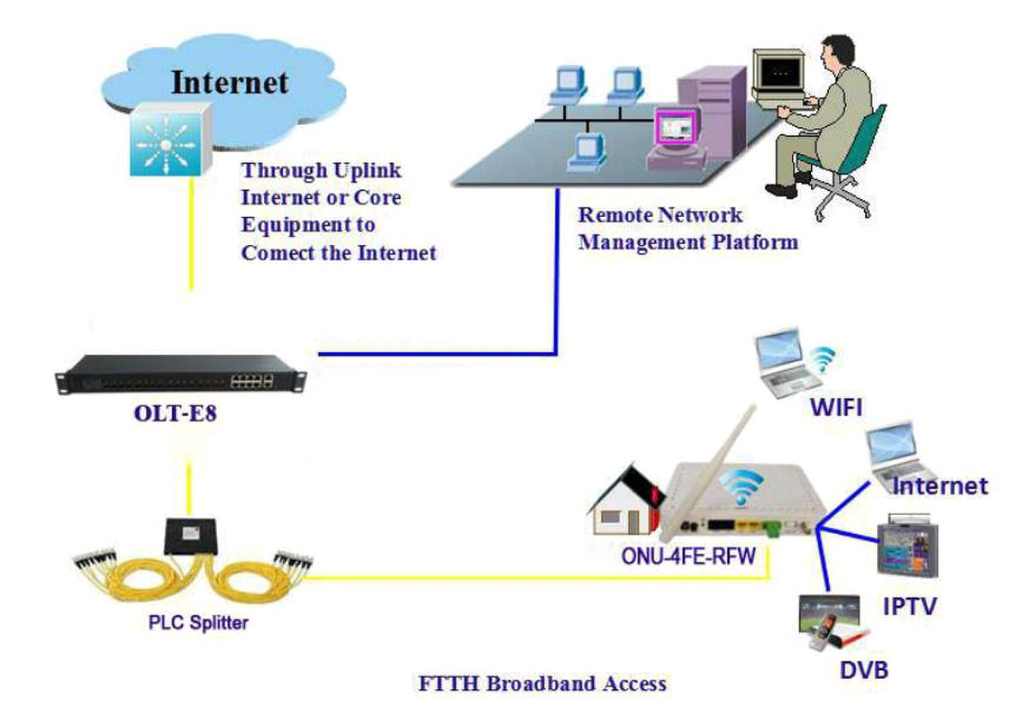
Network Construction
●Figure: ONU-4FE-RFW Application Diagram

