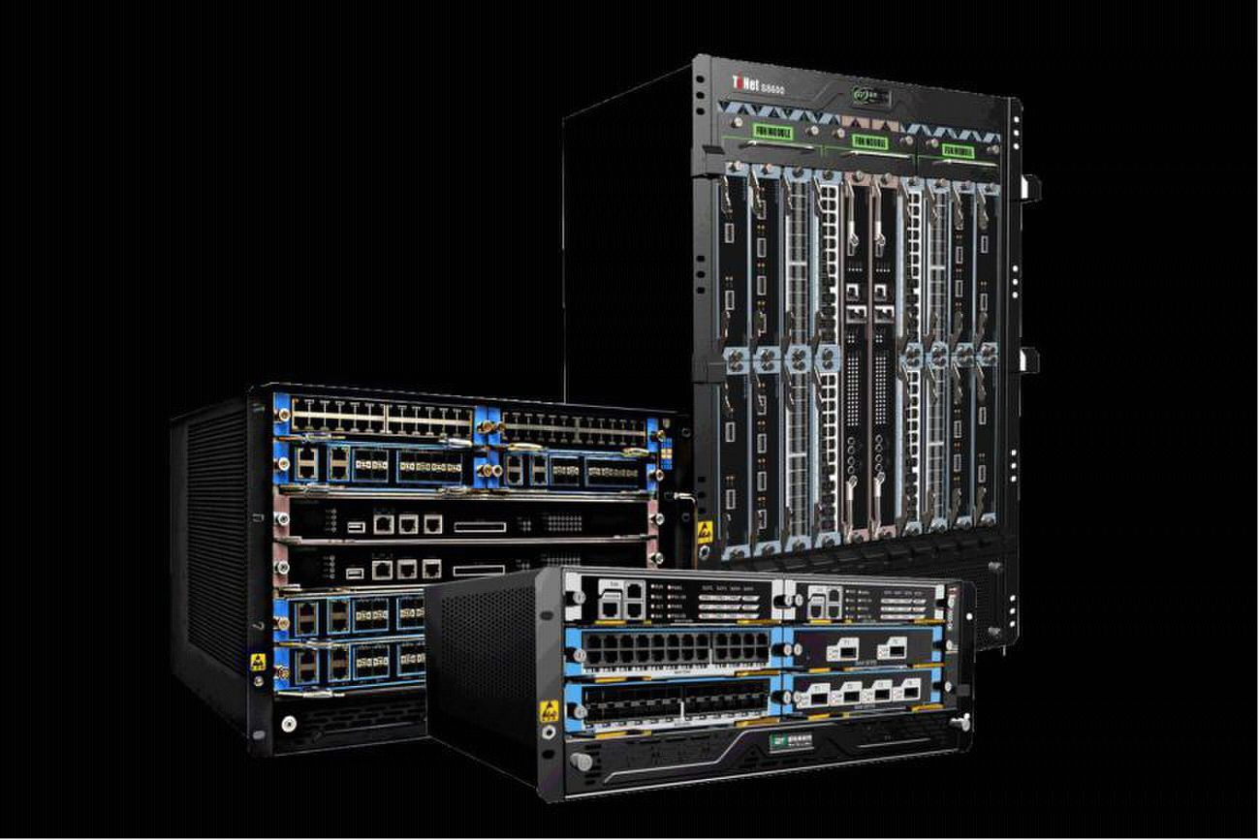
SE8600 Series High-density Terabit Core Switching OLT

Data Sheet

SE8600 series are designed for high-density access switching integrated platform which

combine multi-service and high-density 10G EPON OLT requirement, they are deployed

for high-density EPON OLT as carrier broadband access network.SE8600 series have the

unique half-size slot service cards for the highest density EPON/GPON/10GE/10GEPON

port and terabit switching net can provide the ability of 40/100G future upgrade switching

and smooth upgrade access platform. SE8600 series have the first innovation processing

architecture with fully distributed based on 64-bit multi-core processors and high

performance AISC. They can provide IPv4/IPv6 wire-speed transferring capacity and be

widely used on the IP MANs of carriers, WANs and MANs of enterprises, egress, core

layer, and convergence layer of enterprise

©2016 WirelessVisionltd Co., Ltd All Rights Reserved - 1 -
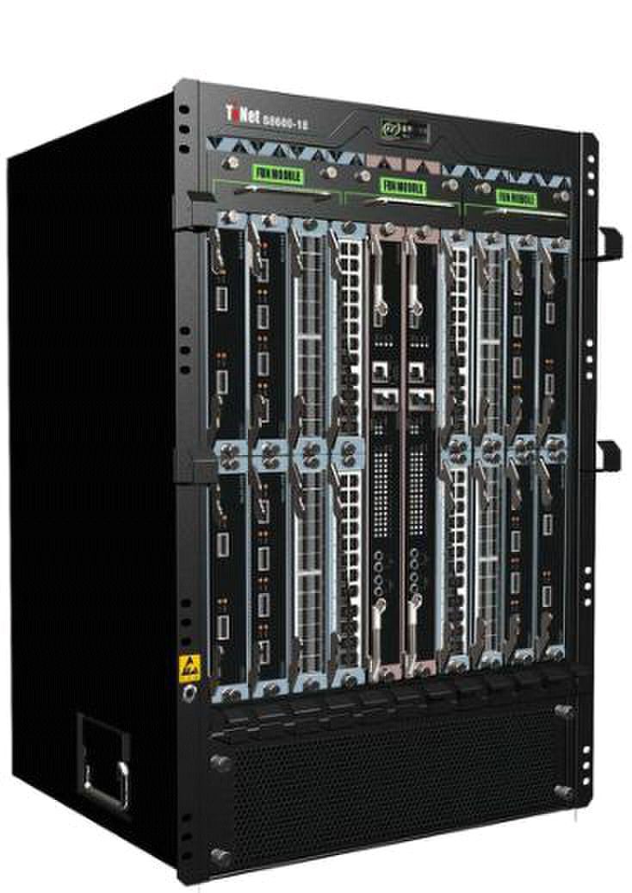
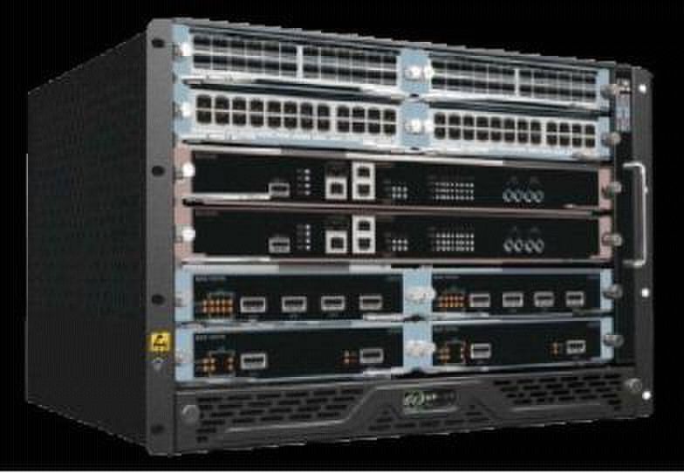
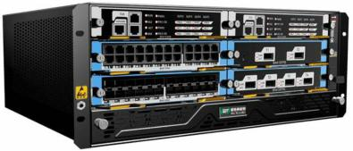
□ 4U compact design, half-size serve slots
SE8600-4
□ 1+1 master control redundancy,1+1power supply

redundancy

□ Hot plug fan chassis, intelligent speed and

temperature control

□ 6slots，2 main control cards,4 line cards

□ Maximum support 32*EPON and 24*GE

□ Support EPON/10GEPON mixed insertion for future

new cards

□ 1.6Tbps widely backplane capacity and smooth

upgrade to 40G/100G

□ IPv4/IPv6 and MPLS hardware line speed forwarding

□ The whole power consumption less than 350W

SE8600-8 □ 9U compact design, half-size serve slots

□ 1+1 master control redundancy,1+1power supply

redundancy

□ Hot plug fan chassis, intelligent speed and

temperature control

□ 10slots，2 main control cards,8 line cards

□ Maximum support 64*EPON and 48*GE

□ Support EPON/10GEPON mixed insertion for future

new cards

□ 3.2Tbps widely backplane capacity and smooth

upgrade to 40G/100G

□ IPv4/IPv6 and MPLS hardware line speed forwarding

□ The whole power consumption less than 680W

SE8600-16

□ 15U compact design, half-size serve slots

□ 1+1 master control redundancy,2+2power supply

redundancy

□ Hot plug fan chassis, intelligent speed and

temperature control

□ 18slots，2 main control cards,16 line cards

□ Maximum support 128*EPON and 96*GE

□ Support EPON/10GEPON mixed insertion for future

new cards

□ 6.4Tbps widely backplane capacity and smooth

upgrade to 40G/100G

□ IPv4/IPv6 and MPLS hardware line speed forwarding

□ The whole power consumption less than1200W

©2016 WirelessVisionltd Co., Ltd All Rights Reserved - 2 -
Product Specification:

Item | SE8600-4 |  | SE8600-8 | SE8600-16
Backplane | >1.6Tbps |  | >3.2Tbps | >6.4Tbps
capacity
Switching | 960Gbps |  | 1.6Tbps | 3.2Tbps
capacity
Throughput(IPv | 720Mpps |  | 1440Mpps | 2860Mpps
4/IPv6)
Number of slots | 6 |  | 10 | 18
Number of | 4 |  | 8 | 16
service board
slots
Service port | Up to 32*EPON and | Up to 64*EPON and |  | Up to 128*EPON and
 | 24*GE | 48*GE |  | 96*GE
Redundancy | 1+1 power redundancy |  | 1+1 power redundancy | 2+2 power redundancy
 | 1+1 main control |  | 1+1 main control | 1+1 main control
design
 | redundancy |  | redundancy | redundancy
Power supply | AC：90～260V，50～ | 60Hz；
 | DC：-36V～-72V；
Power | ≤300W |  | ≤680W | ≤1200W
consumption
Outline | 442mm×176mm×420mm |  | 442mm×310mm×420mm | 442mm×664mm×420mm
dimensions
(mm) (W*D*H)
Weight (in | ≤15kg |  | ≤25kg | ≤45kg
maximum
configuration)
Environmental | Working temperature：0°C～40°C
 | Storage temperature：-40°C～70°C
parameter
 | Relative humidity：10%～90%，no condensing

Business Features:

Attributes | SE8600 Series
PON features | IEEE 802.3ah EPON
 | China telecom/Unicom | GEPON standard
 | 20Km for single fibber
 | Access 64 terminals for single fibber PON
 | Uplink and downlink triple churning encrypted function
 | ONU terminal legitimacy certification, report illegal ONU registration
 | DBA algorithm
 | Standard OAM and extended OAM
 | ONU batch software upgrade, fixed time upgrade, real time upgrade
 | PON transmit and inspect receiving optical power

©2016 WirelessVisionltd Co., Ltd All Rights Reserved - 3 -
L2 features | MAC | MAC Black Hole
 |  | Port MAC Limit
 |  | MAC address limitation based on ONU
 | VLAN | 4K VLAN entries
 |  | Port-based/MAC-based/IP subnet-based VLAN
 |  | Port-based QinQ and Selective QinQ (StackVLAN)
 |  | VLAN Swap and VLAN Remark and VLAN Translate
 |  | GVRP
 |  | Based on ONU service flow VLAN add, delete, replace
Spanning |  | IEEE 802.1D Spanning Tree Protocol (STP)
 |  | IEEE 802.1w Rapid Spanning Tree Protocol (RSTP)
tree
 |  | IEEE 802.1s Multiple Spanning Tree Protocol instances (MSTP)
protocol
 |  | ONU remote loop detecting alarm
 | Port
 |  | Static link aggregation and LACP(Link Aggregation Control Protocol)
 |  | Port mirroring and traffic mirroring
 | User | Anti-ARP-spoofing
 |  | Anti-ARP-flooding
 |  | IP Source Guard create IP+VLAN+MAC+Port binding
 |  | Port Isolation
 |  | MAC address binds to port and port MAC address filtration
 | security
 |  | IEEE 802.1x and AAA/Radius authentication
 |  | TACACS+ authentification
 |  | dhcp anti-attack flood attack automatic suppression
 |  | ONU isolation control
Security | Device | Anti-DOS attack(such as ARP，Synflood, Smurf, ICMP attack), ARP detection,
 |  | worm and Msblaster worm attack
 |  | SSHv2 Secure Shell
 | security | SNMP v3 encrypted management
features
 |  | Security IP login through Telnet
 |  | Hierarchical management and password protection of users
 | Network | User-based MAC and ARP traffic examination
 |  | Restrict ARP traffic of each user and force-out user with abnormal ARP traffic
 |  | Dynamic ARP table-based binding
 |  | Supports IP+VLAN+MAC+Port binding
 |  | L2 to L7 ACL flow filtration mechanism on the 80 bytes of the head of
 |  | user-defined packet
 | security
 |  | Port-based broadcast/multicast suppression and auto-shutdown risk port
 |  | URPF to prevent IP address counterfeit and attack
 |  | DHCP Option82 and PPPoE+ upload user’s physical location
 |  | Plaintext authentication of OSPF、RIPv2 and BGPv4 packets and MD5
 |  | cryptograph authentication
IP routing
 | IPv4 | ARP Proxy
 |  | DHCP Relay
 |  | DHCP Server
 |  | Static route

©2016 WirelessVisionltd Co., Ltd All Rights Reserved - 4 -
 |  | RIPv1/v2
 |  | OSPFv2
 |  | BGPv4
 |  | Strategy route
 |  | Route policy
 | IPv6 | ICMPv6
 |  | ICMPv6 redirection
 |  | DHCPv6
 |  | ACLv6
 |  | OSPFv3
 |  | RIPng
 |  | BGP4+
 |  | Configured Tunnel
 |  | ISATAP
 |  | 6to4 tunnel
 |  | IPv6 and IPv4 Tunnels
 | ACL | Standard and extended ACL
 |  | Time Range ACL
 |  | Packet filter providing filtering based on source/destination MAC address,
 |  | source/destination IP address, port, protocol, VLAN, VLAN range, MAC address
 |  | range, or invalid frame. System supports concurrent identification at most 50
 |  | service traffic
 |  | Support packet filtration of L2～L7 even deep to 80 bytes of IP packet head
Service | QoS | Rate-limit to packet sending/receiving speed of port or self-defined flow and
 |  | provide general flow monitor and two-speed tri-color monitor of self-defined flow
 |  | Priority remark to port or self-defined flow and provide 802.1P, DSCP priority and
 |  | Remark
 |  | CAR(Committed Access Rate)、Traffic Shaping and flow statistics
 |  | Packet mirror and redirection of interface and self-defined flow
 |  | Super queue scheduler based on port and self-defined flow. Each port/ flow
 |  | supports 8 priority queues and scheduler of SP, WRR and SP+WRR.
 |  | Congestion avoid mechanism，including Tail-Drop and WRED
features
 | Multicast | IGMPv1/v2/v3
 |  | IGMPv1/v2/v3 Snooping
 |  | IGMP Filter
 |  | MVR and cross VLAN multicast copy
 |  | IGMP Fast leave
 |  | IGMP Proxy
 |  | PIM-SM/PIM-DM/PIM-SSM
 |  | PIM-SMv6、PIM-DMv6、PIM-SSMv6
 |  | MLDv2/MLDv2 Snooping
 | MPLS | L3 MPLS VPN
 |  | L2 VPN: VLL (Martini, Kompella)
 |  | MCE
 |  | MPLS OAM
Reliability | Loop | EAPS and GERP (recover-time <50ms)
 | protection | Loopback-detection

©2016 WirelessVisionltd Co., Ltd All Rights Reserved - 5 -
 | Link | FlexLink (recover-time <50ms)
 |  | RSTP/MSTP (recover-time <1s)
 | protection | LACP (recover-time <10ms)
 |  | BFD
 | Device | VRRP host backup
 |  | Double fault-tolerant backup of host program and configuration files
 |  | 1+1 main control panel hot backup
 | protection
 |  | 1+1 power hot backup
 |  | Fan redundancy
Maintenan | Network | Telnet-based statistics
 |  | RFC3176 sFlow
 |  | LLDP
 | maintena
 |  | 802.3ah Ethernet OAM
 | nce
 |  | RFC 3164 BSD syslog Protocol
 |  | Ping and Traceroute
ce | Device | Command-line interface（CLI）, Console, Telnet and WEB configuration
 |  | System configuration with SNMPv1/v2/v3
 |  | RMON (Remote Monitoring)1/2/3/9 groups of MIB
 | managem
 |  | NTP(Network Time Protocol)
 | ent
 |  | GN.LinkⅡ Server
 |  | NGBNView network management

Purchase Information:

Product Name | Product Description
SE8600-04 | 6slots(4*service slots,2*main control slots,1*hot plug fan disk, no main control
 | boards, no power supply)
SE8600-08 | 10slots(8*service slots,2*main control slots,1*hot plug fan disk, no main control
 | boards, no power supply)
SE8600-16 | 18slots(16*service slots,2*main control slots,2*hot plug fan disk, no main control
 | boards, no power supply)
NG01MSUA0 | SE8600-04, main control boards, NGEngine™ I switch routing engine
NG02MSUA0 | SE8600-08/16, main control boards, NGEngine™Ⅱ switch routing engine
NG03MSUA0 | SE8600-08/16, main control boards, NGEngine™Ⅲ switch routing engine
NG01PWR750A1 | SE8600,750W dual power supply module A1
NG01PWR1000A1 | SE8600,1000W dual power supply power A1
NG01EP08SA | 8600,EPON service card,8*EPON SFP,4*1000BaseX SFP,2*100/1000Base-T, SI
NG01EP08MA | 8600,EPON service card,8*EPON SFP,4*1000BaseX SFP,2*100/1000Base-T, MI
NG01GS24SA | SE8600, switch routing service card,24*1000BaseX SFP interface, SI
NG01GS24MA | SE8600, switch routing service card,24*1000BaseX SFP interface, MI
NG01GT24SA | SE8600, switch routing service card,24*10/100/1000BaseT interface, SI
NG01GT24MA | SE8600, switch routing service card,24*10/100/1000BaseT interface, MI
NG01SFP+04SA | SE8600, switch routing service card,4*10GE SFP+10GE interface, SI
NG01SFP+04MA | SE8600, switch routing service card,4*10GE SFP+10GE interface, MI

©2016 WirelessVisionltd Co., Ltd All Rights Reserved - 6 -
NG01SFP+08SA | SE8600, switch routing service card,8*10GE SFP+10GE interface, SI
NG01SFP+08MA | SE8600, switch routing service card,8*10GE SFP+10GE interface, MI
NG01SFP+12SA | SE8600, switch routing service card,12*10GE SFP+10GE interface, SI
NG01SFP+12MA | SE8600, switch routing service card,12*10GE SFP+10GE interface, MI
NG01EP08SA | SE8600, switch routing service card,12*10GE SFP+10GE interface, SI
NG01EP08MA | SE8600, switch routing service card,12*10GE SFP+10GE interface, MI

©2016 WirelessVisionltd Co., Ltd All Rights Reserved - 7 -

