In compliant with IEEE802.3ah Standard and CTC2.1

Up to 20KM transmission Distance

Support VLAN and IGMP

Support port isolation between different ports

Integrated OAM remote configuration and maintenance function

Plug and play, integrated auto detecting, auto configuration, and auto firmware

EMS network management based on SNMP, convenient for maintenance
4FE+ 1POTS +CATV +Wi-Fi Single Fiber EPON ONU

ONU-4FE-VRF-W 4FE+ 1POTS +CATV +Wi-Fi

Single Fiber EPON ONU
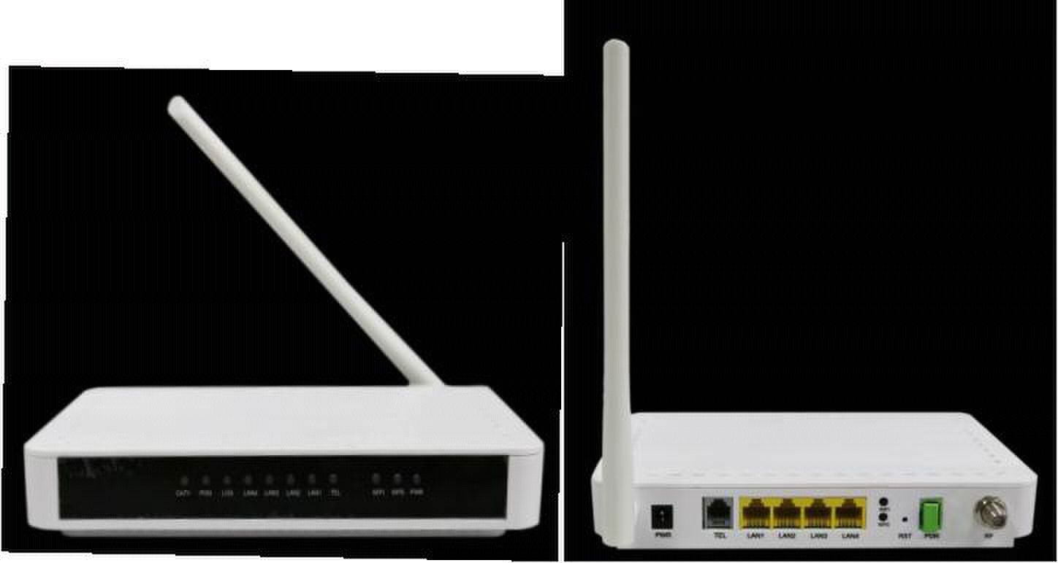
Brief Views

ONU-4FE-VRF-W(4FE+1POTS+RF+Wi-Fi) is a FTTH bandwidth access equipment. Based on

mature and stable EPON technology, it has powerful functions with high stability, sound QoS

guarantee, comprehensive management and flexible networking construction, etc. ONU

ONU-4FE-VRF-W’s technology standard fully complies with ITU-T, IEEE and

telecommunication technology standard.

It adopts single fiber WDM technology with downlink wavelength 1490nm, uplink

wavelength 1310nm. It only needs one-core fiber to transmit data service.

ONU FD404FI has 1 PON port, 1 POTS port, four10/100BASE-T ports and one CATV output,

support Wi-Fi function.

Functional Feature

■

■

■

■

■

■

upgrade technology

■

- 1 -
Full speed non-blocking switching.

Support QinQ VLAN, 1:1 VLAN, VLAN reusing, VLAN trunk, etc.

Integrated port monitoring, port mirroring, port rate limiting, port SLA, etc.

Support auto polarity detection of Ethernet ports (AUTO MDIX).

Integrated IEEE802.1p QoS with four level priority queues.

Support IPv4 IGMP snooping and IPv6 MLD snooping.

Support SIP (compatible with IMS), H.248, MGCP three VoIP protocol, and the soft

With the heartbeat function, support the main producing soft exchange platform;

Support ITU-T G.711, G.723.1, G.729 and other three kinds of compression

Support high / low speed mode transparent transmission, T38 two fax;

Support high-speed Modem (56Kbps) dial access; support RFC2833 and redundant

Support 1 POTS interface and the three party call, three party support local mixing;

Support POTS port GR909 line test function;

Support dynamic PPPoE, DHCP and static IP;

7 * 24 hour call loss is less than or equal to 0.01%;

Turn on/off RF output remotely
4FE+ 1POTS +CATV +Wi-Fi Single Fiber EPON ONU

■

■

■

■

■

■

Voice Service Functions

■

switch platform the mainstream can be good intercommunication;

■

■

algorithm; echo cancellation conforming to ITU-T G.168-2002, an echo canceller for

the longest 128ms;

■

■

RFC2833, ringing, MD5 certification, call forwarding, call waiting, the hotline, alarm

clock, abbreviated dialing and other value-added services;

■

■

■

■

CATV Service Functions

■

■ Wavelength：1550 +/- 10nm

■ Optical return loss：>45dB

■ Input optical power：-8dBm～+2dBm

■ RF frequency：47MHz~875MHz

■ RF output lever：75～80dBuV

■ CNR：>46dB，CSO: >58dBc，CTB: >58dBc

■ RF output return loss：>14dB

■ RF impedance： 75Ohm

- 2 -
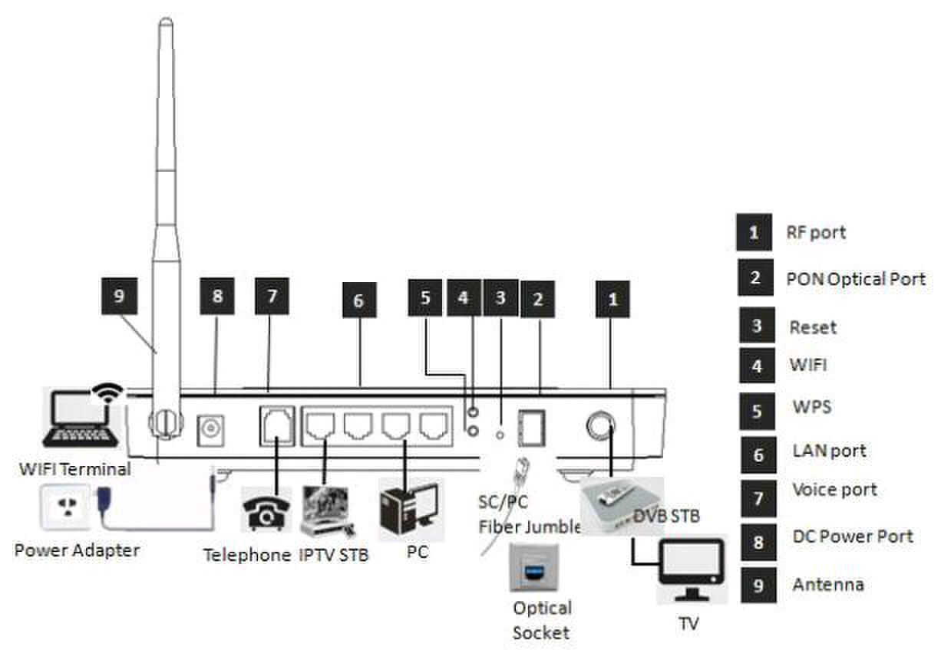
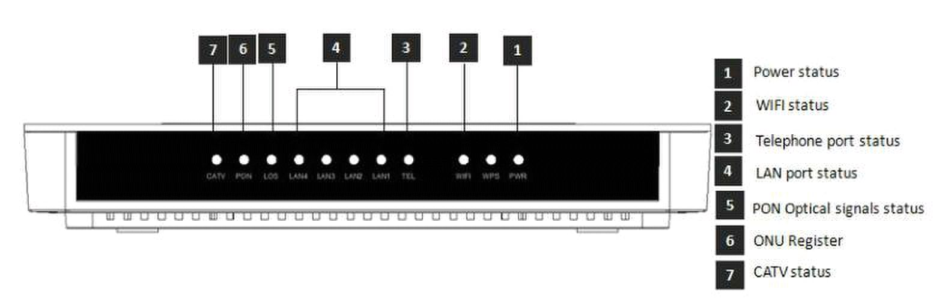
4FE+ 1POTS +CATV +Wi-Fi Single Fiber EPON ONU

Product interface and LED definitions

Indicator |  |  | Description
1 | PWR | Power status | On: The ONU is power on
 |  |  | Off: The ONU is Power off
2 | WIFI | WIFI |  |  |  |  |  |  | ：
 |  |  |  | Blinking |  |  |  |  |  | Data is being transmitted
 |  |  |  |  | ：
 |  |  |  | On |  |  | Wi-Fi function Opens
3 | TEL | Telephone port | On |  | ： |  | The connection between the TEL port and the
 |  |  | voice server has been set up
 |  |  | Blinking |  |  |  |  |  | ： | The voice service of the TEL port is
 |  | status | established
 |  |  | Off |  |  | ： |  | The connection between the TEL port and the
 |  |  | voice server is not set up.
4 | LAN1-4 | LAN port status | On: Ethernet connection is normal
 |  |  | Blinking: Data is being transmitted through the
 |  |  | Ethernet port
 |  |  | Off: Ethernet connection is not set up
5 | LOS | EPON optical signals | On: Optical power lower than receiver sensitivity ;
 |  |  | Off: Optical in normal
6 | PON | ONU Register | On: Success to register to OLT
 |  |  | Blinking: In process of registering to OLT
 |  |  | Off: Failed to register to OLT;
7 | CATV | CATV status |  |  | ： |  |  |  |  |  | （ |  |  |  | ） |  | （ | <-9dBm | ）
 |  |  |  | On |  |  | CATV optical normal |  |  |  |  |  | >-9dBm
 |  |  |  |  |  | ：
 |  |  |  | Off |  |  |  | The CATV signals are not received

- 3 -
4FE+ 1POTS +CATV +Wi-Fi Single Fiber EPON ONU

Specification

Item |  |  |  | Parameter
Interface |  | Uplink Interface
 |  |  |  | PON Interface:
 |  |  |  | 1 EPON optical interface
 |  |  |  | Meet 1000BASE-PX20+ standard
 |  |  |  | Symmetric 1.25Gbps upstream/downstream
 |  |  |  | SC single-mode fiber
 |  |  |  | split ratio: 1:64
 |  |  |  | Transmission distance 20KM
 |  |  | POTS Port | 1*RJ11 with 3REN
 |  |  |  | Max 1km distance
 |  |  |  | Balanced Ring, 55V RMS
 |  |  | CATV Interface | 1 RF output
 |  |  |  | Female F-Type Connector
 |  |  | Ethernet Interface | 4*10/100Mauto-negotiation
 |  |  |  | Full/half duplex mode
 |  |  |  | RJ45 connector
 |  |  |  | Auto MDI/MDI-X
 |  |  |  | 100m distance
 |  |  | Power Interface | 12V DC Power supply
PON Optical Parameter |  |  |  | Wavelength: Tx1310nm, Rx1490nm
 |  |  |  | Tx Optical Power: -1～4dBm
 |  |  |  | Rx Sensitivity: -27dBm
 |  |  |  | Saturation Optical Power: -3dBm
 |  |  |  | Connector Type: SC
 |  |  |  | Optical Fiber: 9/125ɥm single-mode fiber
Performance |  |  | Data Transmission | PON | Throughput: | Downstream | 950Mbps; | Upstream
 |  |  |  | 930Mbps
Parameters |  |  |  | Ethernet: 100Mbps
 |  |  | Parameter
 |  |  |  | Packet Loss Ratio: <1*10E-12
 |  |  |  | latency: <1.5ms
 |  |  | Business Capability | Layer 2 wire speed switching
 |  |  |  | Support VLAN TAG/UNTAG，VLAN conversion
 |  |  |  | Support Port-based speed limitation
 |  |  |  | Support Priority classification
 |  |  |  | Support storm control of broadcast
 |  |  |  | Support link detection

- 4 -
4FE+ 1POTS +CATV +Wi-Fi Single Fiber EPON ONU
Network |  | Management Mode |  | Support IEEE802.3 QAM, ONU can be remotely managed by
 |  |  |  | OLT
 |  |  |  | Support Remote management through SNMP and Telnet
Management |  |  |  | Local management
 |  |  | Management Function | Status monitor, Configuration management, Alarm
 |  |  |  | management, Log management
Physical Features |  |  | Shell | Plastic casing
 |  |  | Power | External 12VDC/1A power supply adapter
 |  |  |  | Power consumption: <9W
 |  |  | Dimension and Weight | Item Dimension：200mm(L) x 140mm(W) x 33mm (H)
 |  |  |  | Item weight：0.6kg
 |  |  | Environmental | Operating temperature: 0 to 50ºC
 |  |  |  | Storage temperature: -40 to 85ºC
 |  |  | Specifications | Operating humidity: 10% to 90%(Non-condensing)
 |  |  |  | Storage humidity: 5% to 95%(Non-condensing)

Wi-Fi Specification

Performance | Operating Mode | Router or bridge
 | Throughput | IEEE 802.11b: 11Mbps
 |  | IEEE 802.11g: 54 Mbps
 |  | IEEE 802.11n: 135Mbps
 | Frequency | 2.412 ~ 2.472 GHz
 | Channel | 13*Channel, configurable to meet the standard of USA,
 |  | Canada, Japan and China
 | Modulation | DSSS, | CCK and OFDM
 | Coding | BPSK, QPSK, 16QAM and 64QAM
 | RF receive sensitivity | 802.11b: -82dBm @ 1 Mbps; -80dBm @ 2 Mbps;
 |  | -78dBm @ 5.5 Mbps; -76dBm @ 11 Mbps
Parameters |  | 802.11g: -82dBm @ 6 Mbps; -81dBm @ 9 Mbps;
 |  | -79dBm @ 12 Mbps; -77dBm @ 18 Mbps;
 |  | -74dBm @ 24 Mbps; -70dBm @ 36 Mbps;
 |  | -66dBm @ 48 Mbps; -65dBm @ 54 Mbps
 | RF output lever | 802.11b: |  | 16.5 ±1dBm
 |  | 802.11g: |  | 13 ± 1dBm @ 54 Mbps; 14 ± 1dBm @ 48
 |  | Mbps; 15 ± 1dBm @ 6 ~ 36 Mbps
 |  | 802.11n: |  | 13 ± 1dBm @ 54 Mbps; 14 ± 1dBm @ 48
 |  | Mbps; 15 ± 1dBm @ 6 ~ 36 Mbps
 | Encryption Mode | 802.11i security: WEP-64/128, TKIP (WPA-PSK) and AES
 |  | (WPA2-PSK)

- 5 -
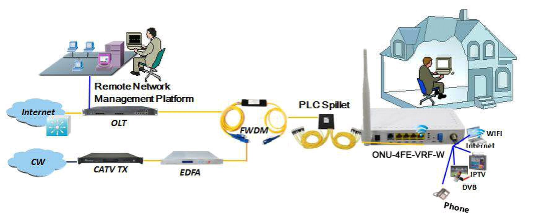
Typical Solution: FTTH, FTTO, PON+EOC

Typical Business: INTERNET, VOICE, CATV, IPTV, VOD, IP Camera, Wi-Fi
4FE+ 1POTS +CATV +Wi-Fi Single Fiber EPON ONU

Application





Network Construction

Ordering information

Product Name | Product Model | Descriptions
4FE + 1POTS + CATV+ Wi-Fi | ONU-4FE-VRF-W
 |  | 4*10/100M Ethernet interface, 1 EPON interface, 1 POTS
EPON ONU |  | interface, support Wi-Fi function, Plastic casing, external
 |  | power supply adapter

- 6 -

