Overview

IRD2CI-CV can decode transport stream (compliant with MPEG2) from ASI or LNB into audio & video signal.With the help of CAM module,it can decrypt the encrypted programs in the encrypted programs in the input TS. Apart from this, the IRD has 1 ASI and CVBS output.

Features

1.Support 1 Tuner(DVB-C/DVB-S) Input
2. Support QPSK demodulation
3. QPSK modulation frequency: 950~2150MHz, symbol rate: 2~45Msps
4. User can edit various transponders’ information
5. PAL / NTSC TV format
6. PAL / NTSC automatic conversion
7. Auto-Save latest channels
8. 1CVBS outputs, 2 AUDIO outputs
9. 2 PCMCIA Interfaces
10. 1 ASI outputs
11. 2 separate CI modules, each supports decrypt multiple channel Programs
12. One LNB input, one LNB loop-out
13. RS232 data interface

Technical Specification

DVB-CI | Descrambler: DVB-CSA
 | Smart Card interface: ISO7816
 | Interface Card Separation: PCMCIA
Video output | 2 CH CVBS(BNC interface): 576i@25fps, 480i@29.97fps
Audio output | Stereo unbalanced audio: BNC interface
 | Stereo balanced audio: XLR interface
Video Decoding | MPEG-2
Audio Decoding | MEPG1 layer 2
ASI input | BNC interface | Input impedance 75Ω
 | Max transport rate | 49Mbps
ASI output | BNC interface | Output impedance 75Ω
 | Max transport rate | 54Mbps
General | Voltage | AC :100V~240V, 50/60Hz
 | Power | <20W(Max)
 | Temperature | 0~45℃(Operation); -20℃~80℃(Storage)
 | Humidity | 10%~90%
 | Dimension | 482mm*455mm*44.5mm
 | Approx weight | 3.2kg

Principle Chart

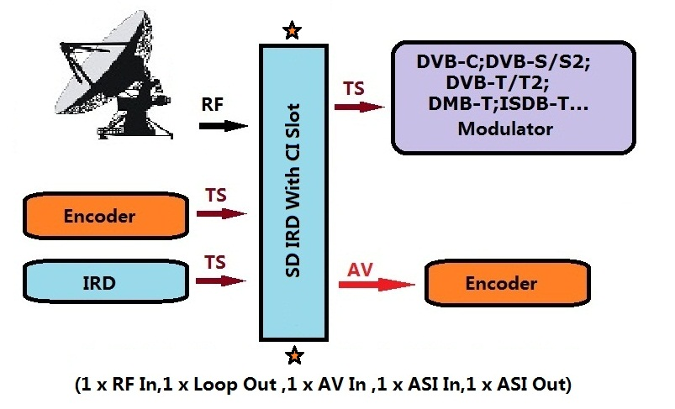

We are expecting to cooperate with you!

