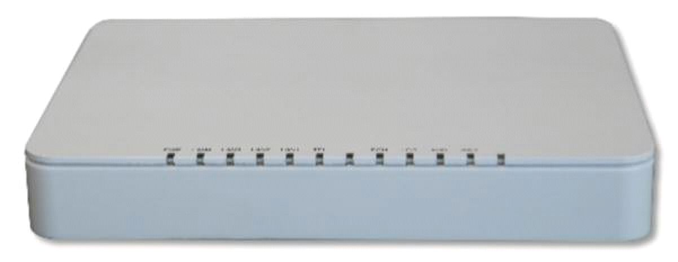
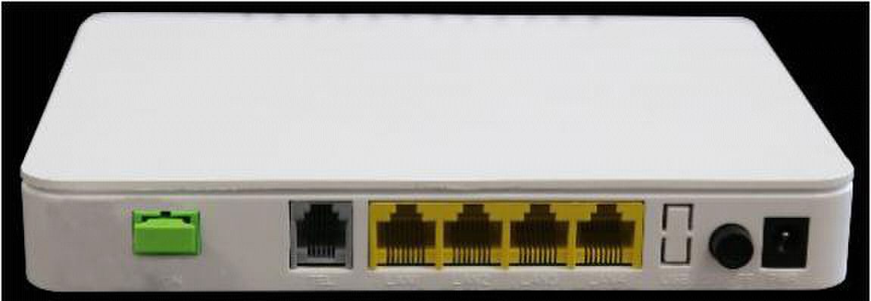
ONU-4FE-V HGU Type EPON ONU

Overview

ONU-4FE-V is one of the EPON optical network unit design to meet the requirement of the

broadband access network. It apply in FTTH/FTTO to provide the data, voice and video

service based on the EPON network.

EPON is the latest generations of access network technology. IEEE802.3ah is the standard

protocol of EPON. The EPON standard differs from other PON standards in that it achieves

higher bandwidth and higher efficiency using larger, variable-length packets. EPON offers

efficient packaging of user traffic, with frame segmentation allowing higher quality of service

(QOS) for delay-sensitive voice and video communications traffic. EPON networks provides

the reliability and performance expected for business services and provides an attractive way

to deliver residential services. EPON enables Fiber To The Home (FTTH) deployments

economically resulting to accelerated growth worldwide.

ONU-4FE-V provide one POTS ports, four FE auto-adapting Ethernet ports. The ONU-4FE-V

features high-performance forwarding capabilities to ensure excellent experience with VoIP,

Internet and HD video services. Therefore, the ONU-4FE-V provides a perfect terminal

solution and future-oriented service supporting capabilities for FTTH deployment. It has

good third-party compatibility to work with the third party OLT, such as

Huawei/ZTE/Fiberhome/Alcatel-Lucen.
Full compatible with IEEE802.3ah

Support one POTS

Support four FE auto-adapting Ethernet ports

Support OAM and TR069 for remote management

Support Web for local management

Support Auto-negotiation and MDI/MDIX

Support the Ethernet interface rate, working mode and flows control

Support loopback at UNI

Support packet filtering and anti-illegal message attack protection

Support performance statistics of Ethernet lines

Support VLAN tagged label processing, traffic classification and packet filtering, STP/RSTP

Support DHCP Option60 reporting the location information of the Ethernet interface

Support PPPoE+ for accurate subscribers identification

Support IGMP Snooping

Support AES-128
Features

❖

❖

❖

❖

❖

❖

❖

❖

❖

❖

❖

etc.

❖

❖

❖ Support H.248、MGCP and SIP protocol

❖

❖
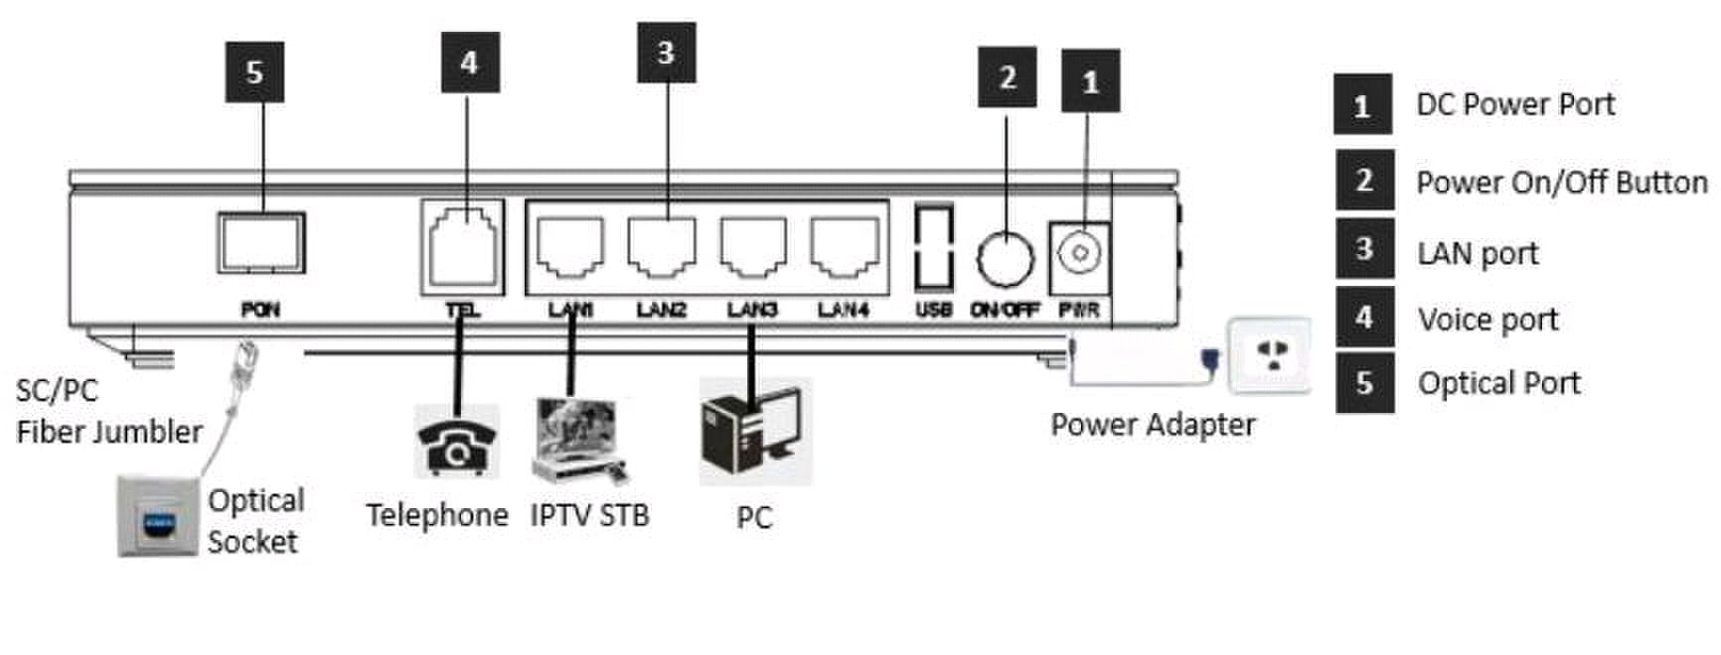
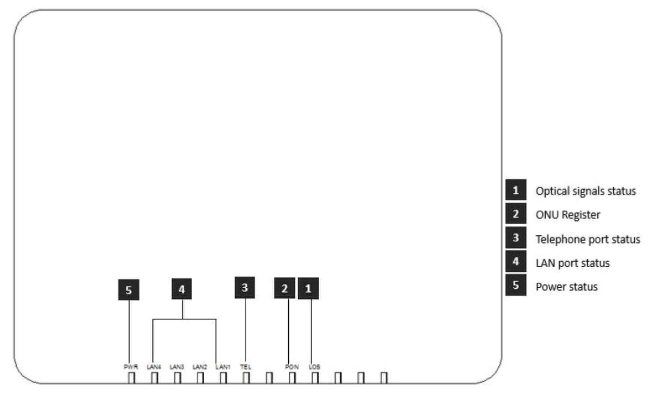
Product Interface and LED Definitions

Indicator |  |  | Description
1 | LOS | EPON optical signals | On: Optical power lower than receiver
 |  |  | sensitivity ;
 |  |  | Off: Optical in normal
2 | PON | ONU Register | On: Success to register to OLT;
 |  |  | Blinking: In process of registering to OLT;
 |  |  | Off: In process of registering to OLT;
3 | TEL | Telephone port status | On: The connection between the TEL port
 |  |  | and the voice server has been set up
 |  |  | Blinking: The voice service of the TEL port
 |  |  | is established;
 |  |  | Off: The connection between the TEL port
 |  |  | and the voice server is not set up.
4 | LANn | LAN port status | On: Ethernet connection is normal;
 |  |  | Blinking: Data is being transmitted through
 |  |  | the Ethernet port;
 |  |  | Off: Ethernet connection is not set up;
5 | PWR | Power status | On: The ONU is power on;
 |  |  | Off: The ONU is Power off;
Specification

Item |  | Parameters |  | Specification
Interface |  | PON Port
 |  |  |  | 1 EPON optical interface
 |  |  |  | Meet 1000BASE-PX20+ standard
 |  |  |  | Symmetric 1.25Gbps upstream/downstream
 |  |  |  | SC single-mode fiber
 |  |  |  | split ratio: 1:64
 |  |  |  | Transmission distance 20KM
 |  |  | Ethernet Port(LAN) | 4*10/100M Auto-negotiation RJ45 ports
 |  |  |  | Full Duplex / Half-Duplex
 |  |  |  | RJ45, Auto-MDI/MDI-X
 |  |  |  | Transmission Distance 100 Meter
 |  |  | POTS Port | 1*RJ11 with 3REN
 |  |  |  | Max 1km distance
 |  |  |  | Balanced Ring, 55V RMS
 |  |  | Power Supply Port | 12V DC input
Management |  |  | Network Management | Standard compliant OAM interface as defined by
 |  |  |  | IEEE802.3ah
 |  |  |  | Support TR-069 and WEB management
 |  |  | Management | Status monitor, Configuration management, Alarm
 |  |  | Function | management, Log management
Environmental |  |  | Shell | Plastic casing
 |  |  | Power | External 12V 1A AC/DC power supply adapter
 |  |  |  | Power consumption: <6W
 |  |  | Dimensions | 170mm(L)*130mm(W)*30mm(H)
 |  |  |  | 0.3kg
Specifications
 |  |  | Environment | Operating Temperature: 0～50℃
 |  |  |  | StorageTemperature: -40 |  | ～85℃
 |  |  |  | Operating Humidity: 10% |  |  | ～ | 90%(Non-condensing)
 |  |  |  | StorageHumidity: 10% | ～90% |  |  |  | (Non-condensing)
FTTO PON+EOC
、 、 、
Solution: FTTH FTTB

、 、 、 、
Application



 Business: Broadband Internet Voice IPTV VOD IP Camera

Network Construction

Ordering Information

Product Name | Product Model | Descriptions
HGU Type EPON ONU | ONU-4FE-V
 |  | 4*FE Ethernet interface, 1*POTS interface, 1*EPON interface,
 |  | plastic casing, external power supply adapter
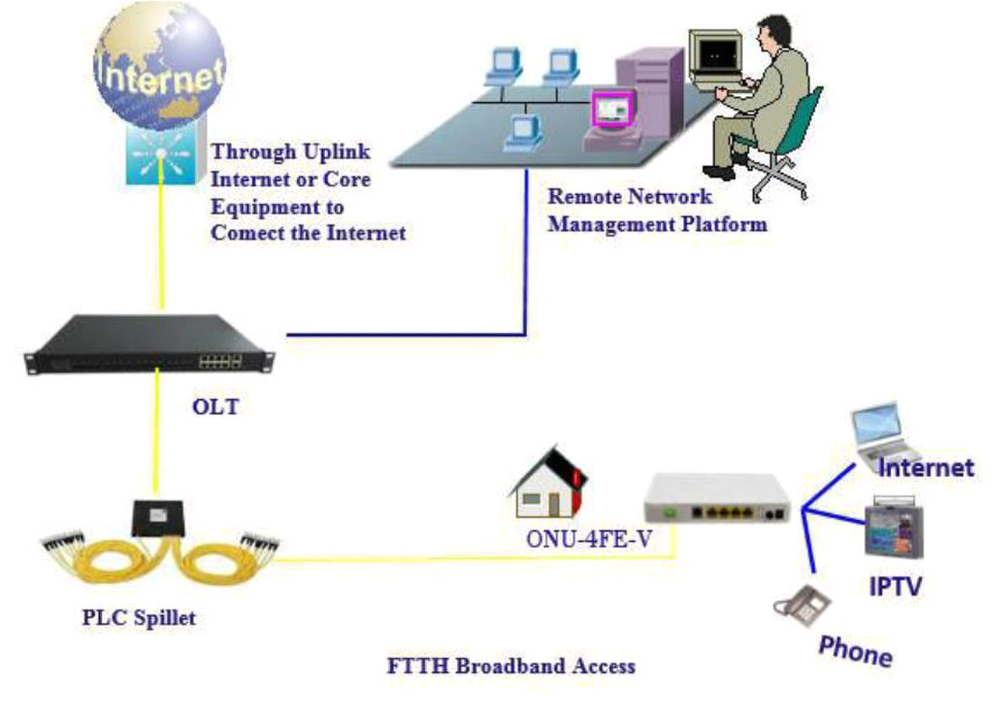

Figure: ONU-4FE-V Application Diagram

