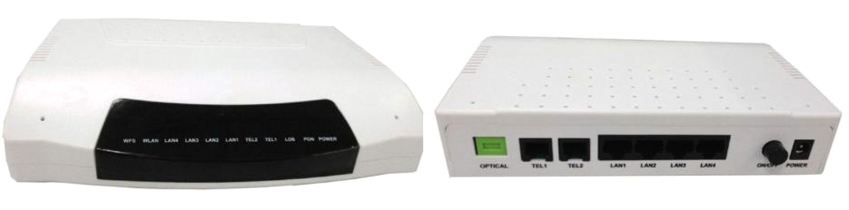
ONT-4FE-2V GPON HGU Manual

ONT-4FE-2V GPON HGU

(4FE+2POTS)

Overview

ONT-4FE-2V GPON HGU is one of the GPON optical network unit design to meet the requirement

of the broadband access network. It apply in FTTH/FTTO to provide the data, voice and video

service based on the GPON network.

GPON is the latest generations of access network technology. ITU-T G.984 is the standard

protocol of GPON. The GPON standard differs from other PON standards in that it achieves higher

bandwidth and higher efficiency using larger, variable-length packets. GPON offers efficient

packaging of user traffic, with frame segmentation allowing higher quality of service (QOS) for

delay-sensitive voice and video communications traffic.GPON networks provides the reliability

and performance expected for business services and provides an attractive way to deliver

residential services. GPON enables Fiber To The Home (FTTH) deployments economically

resulting to accelerated growth worldwide.

ONT-4FE-2V provide two POTS ports, four FE auto-adapting Ethernet ports. The ONT-4FE-2V

features high-performance forwarding capabilities to ensure excellent experience with VoIP,

Internet and HD video services. Therefore, the ONT-4FE-2V provides a perfect terminal solution

and future-oriented service supporting capabilities for FTTH deployment. It has good third-party

compatibility to work with the third party OLT, such as Huawei/ZTE/Fiberhome/Alcatel-Lucen.
Full compatible with ITU-T G.984

Support two POTS

Support four FE auto-adapting Ethernet ports

Support OMCI and TR069 for remote management

Support Web for local management

Support Auto-negotiation andMDI/MDIX

Support the Ethernet interface rate, working mode andflows control

Support loopback at UNI

Support packet filtering and anti-illegal message attack protection

Support performance statistics of Ethernet lines

Support VLAN tagged label processing, traffic classification and packet filtering,

Support DHCP Option60 reporting the location information of the Ethernet interface

Support PPPoE+ for accurate subscribers identification

Support IGMP Snooping

Support AES-128
ONT-4FE-2V GPON HGU Manual

Features

■

■

■

■

■

■

■

■

■

■

■

STP/RSTP etc.

■

■

■ Support H.248、MGCPandSIP protocol

■

■
ONT-4FE-2V GPON HGU Manual

Specification

Item | Parameters | Specification
Interface | PON Port | 1*GPON port, FSAN G.984.2 standard, Class B+
 |  | Downstream Data Rate：2.488Gbps
 |  | Upstream Data Rate：1.244Gbps
 |  | SC/PC single mode fiber
 |  | 28dB Link loss and |  |  | 30KM distance with 1:128
 | Ethernet Port(LAN) | 4*10/100M Auto-negotiation RJ45 ports
 |  | Full Duplex / Half-Duplex
 |  | RJ45, Auto-MDI/MDI-X
 |  | Transmission Distance 100 Meter
 | POTS Port | 2*RJ11 with 2REN
 |  | Max 1km distance
 |  | Balanced Ring, 55V RMS
 | Power Supply Port | 12V DC input
 |  | With 12V 1A AC/DC adapter AC input
Management | NetworkManagement | Standard compliant OMCI interface as defined by
 |  | ITU-T G.984.4
 |  | Support TR-O69
 | Management | Status monitor, Configuration management, Alarm
 | Function | management, Log management
LED Indicator | LEDS | PWR: Power
 |  | LOS: Optical link
 |  | PON: ONU Register
 |  | LAN：Link Status of Ethernet Interface
 |  | TEL: Voice ports
Environmental | Shell | Plastic casing
 | Power | External 12V 1A AC/DC power supply adapter
 |  | Power consumption: <6W
 | Dimensions | 176mm(L) x 134mm(W) x 37mm (H)
 |  | 0.3kg
Specifications
 | Environment | Operating Temperature |  |  |  |  | ：－ |  | 10 | ～ | 45 | ℃
 |  | StorageTemperature |  |  | ：-30～60℃
 |  | Operating Humidity：10%～90%(Non-condensing)
 |  | StorageHumidity | ： | 5% |  | ～ |  | 95%(Non-condensing)

ONT-4FE-2V GPON HGU Manual

Application

 Solution：FTTH、FTTB、FTTO、PON+EOC

 Business：Broadband Internet、Voice、IPTV、VOD、IP Camera

Network Construction
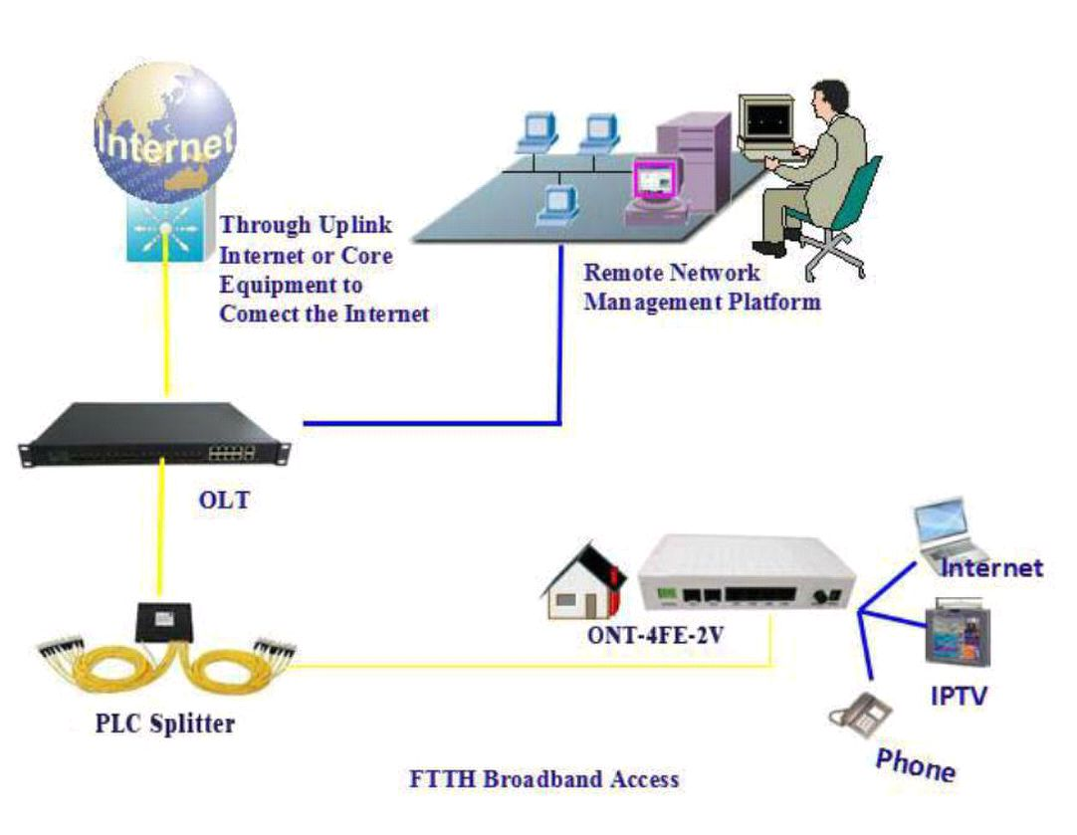

Figure: ONT-4FE-2V Application Diagram

