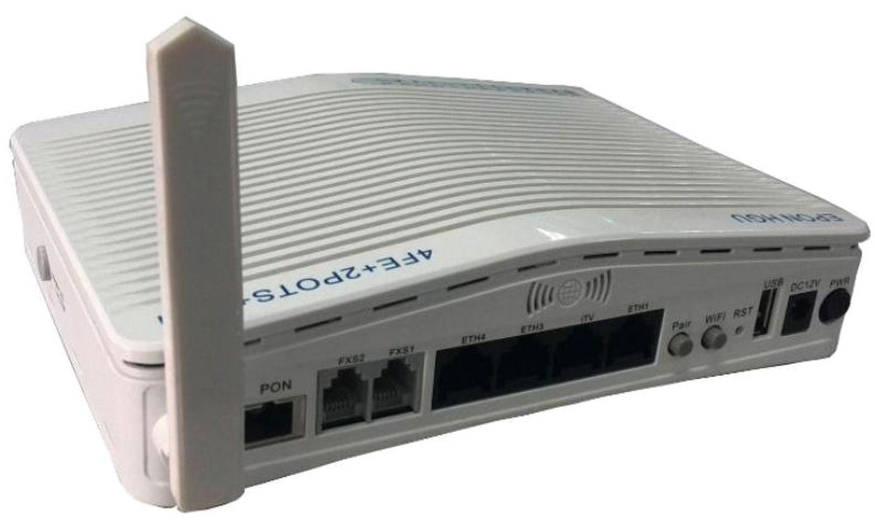
Plug and play, integrated auto detecting, auto configuration, and auto firmware upgrade

Integrated OMCI and TR069 remote configuration and maintenance function.

Support rich QinQ VLAN, DHCP Server/Relay and IGMP/MLD snooping multicast feature.

Support fiber transceiver diagnostic monitoring, fiber transmitter disable remotely.

Fully compatibility with OLT based on Broadcom chipset etc.

Support 802.11n WiFi (2T2R) function.

Support NAT, Firewall function.

Support IPv4 and IPv6 dual stack.
ONT-4GE-2VWX GPON ONT Manual

ONT-4GE-2VWX GPON ONT/HGU

Introduction

ONT-4GE-2VWX is designed for fulfilling FTTH (Fiber To The Home) and triple play service

demand of fixed network operators. It is developed wholly by Guangzhou V-Solution. The box is

based on the mature Gigabit GPON technology, which has high ratio of performance to price, and

the technology of 802.11n WiFi (2T2R), Layer 2&3 and high quality VoIP as well. It is highly

reliable and easy to maintain, with guaranteed QOS for different service. And It is fully compliant

with technical regulations such as ITU-T G.984.x and technical requirement of GPON Equipment

(V2.1 and above version) from China Telecom.

ONT-4GE-2VWX

Special features

●

technology.

●

●

●

●

●

●

●
Integrated line testing compliant with GR-909 on POTS.
ONT-4GE-2VWX GPON ONT Manual

●

● The WAN port supports bridge, router and bridge/router mixed mode.

Technical parameters

Technical items | Descriptions
Chipsets | BCM68380F
Optical interface | 1 GPON interface, SC single-mode/single-fiber, Downstream rate 2.5Gbps,
 | Upstream rate 1.25Gbps
Optical Wavelength | Tx 1310nm, Rx 1490nm
Optical interface | SC/PC
RX sensitivity | < -25dBm @ 1490nm
WLAN | Compliant with IEEE802.11b/g/n, 300Mbps, 2T2R
 | one internal antenna and one external antenna
WLAN throughput | 100Mbps @ 40users, 1518bytes, no-encryption
 | 107Mbps @ 40users, 512bytes, encryption
LAN interface | 4*10/100Mbps
 | Auto adaptive Ethernet interfaces, Full/Half Duplex, RJ45 connectors
Router throughput | Upstream: >390Mbps @ 1518bytes, Downstream: >390Mbps @ 1522bytes
POTS interface | 2 FXS, RJ11 connectors
Indicators | 14 indicators
DC power supply | +12V@1A, external AC-DC power adaptor
Button | RST, Power, WiFi, WPS, Pair
Power | ≤ 10W
consumption
Operating | Operating temp: -5 ~ +55 |  | ℃ |  | ,Operating humidity: 10~90% (non-condensed)
condition
Storing condition | Storing temp: -30 ~ +60 | ℃ |  | ,Storing humidity:10~90%(non-condensed)
Dimension | 205mm*138mm*50mm(length*width*height)
Net weight | 0.4Kg

Data Service Functions

1) Full speed non-blocking switching.

2) 2048 MAC address table.

3) 64 full range 4095 VLAN ID

4) Support VLAN QinQ, transparent, tag, translation, trunk, etc.

5) Integrated port monitoring, port mirroring, port rate limiting, port SLA, etc.

6) Support auto polarity detection of Ethernet ports (AUTO MDIX).

7) Integrated IEEE802.1p QoS with four level priority queues.

8) Support IPv4 IGMP snooping and IPv6 MLD snooping.

9) Support bridging, router and bridging/router mixed mode.
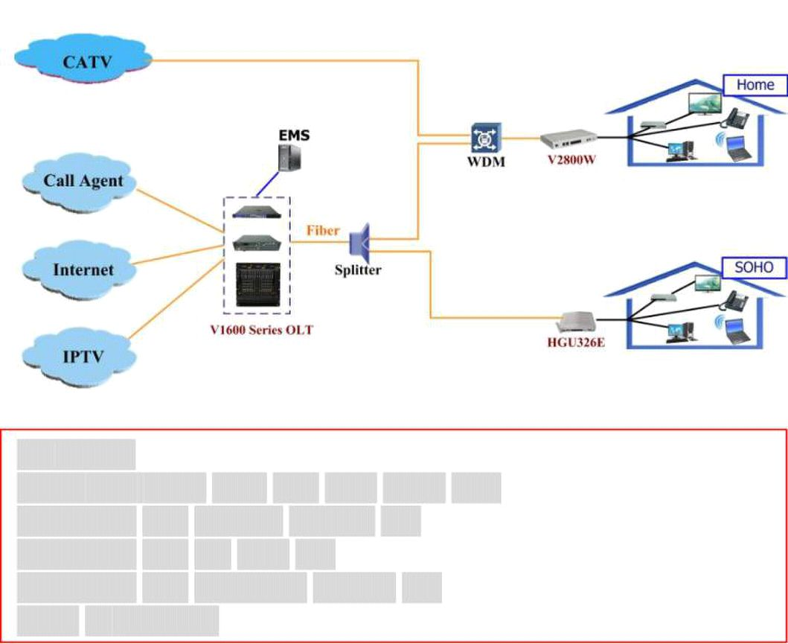
ONT-4GE-2VWX GPON ONT Manual

POTS Service Functions

1) Call protocol: SIP (IMS compatible), seamless compatible with all popular call agent.

2) Integrate heartbeat function and support active/standby call agent.

3) Voice coding: ITU-T G.711/G.723.1(5.3K/6.3Kbit/s)/G.729, auto-negotiate with call agent.

4) Echo cancellation exceeding ITU-T G.165/G.168-2002, up to 128ms tail length.

5) Support high/low speed fax/Modem, bypass fax, and T38 fax.

6) Support RFC2833 and redundant RFC2833, difference rings, MD5 authentication, call

forward, call waiting, hot-line call, alarm clock, and all kinds of value-added voice service.

7) Multi-party conferencing.

8) Line testing according to GR-909.

9) IP address assignment: dynamic PPPoE/DHCP Client and static IP.

10) Support WEB, CLI, TR069.

11) Integrated OAM, XML, DHCP option 66 & 67 for auto configuration and firmware upgrade.

12) Call loss is less than 0.01%.

WiFi service

1) Integrated 802.11b/g/n, 300Mbps, 2T2R.

2) Support 128 connections.

3) Support WEP and WPA/WPA2 security protocols.

Application chart

Key Words:

GPON ONT, GPON HGU, WiFi ONT, GPON ONU

Compatible with HUAWEI M5680T OLT

Compatible with ZTE C300 OLT

Compatible with Fiberhome AN5516 OLT

Based on BCM6838
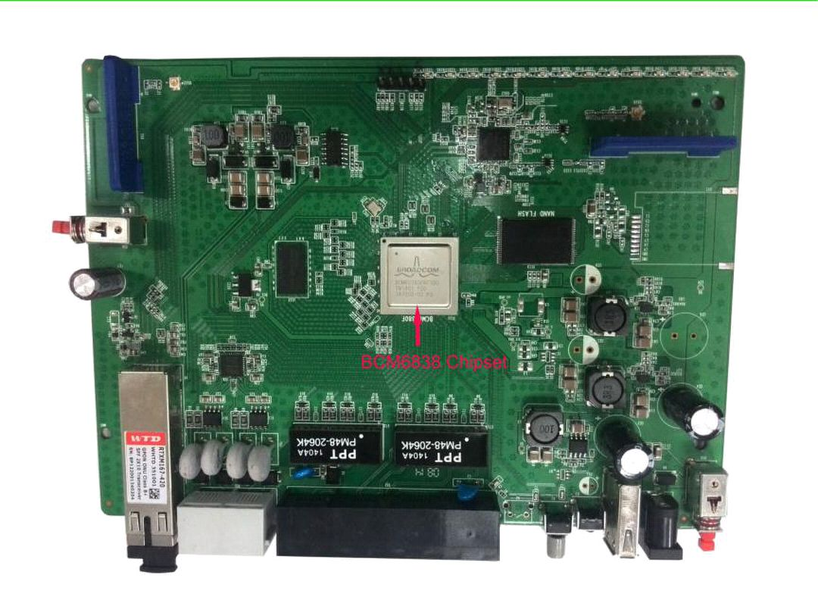
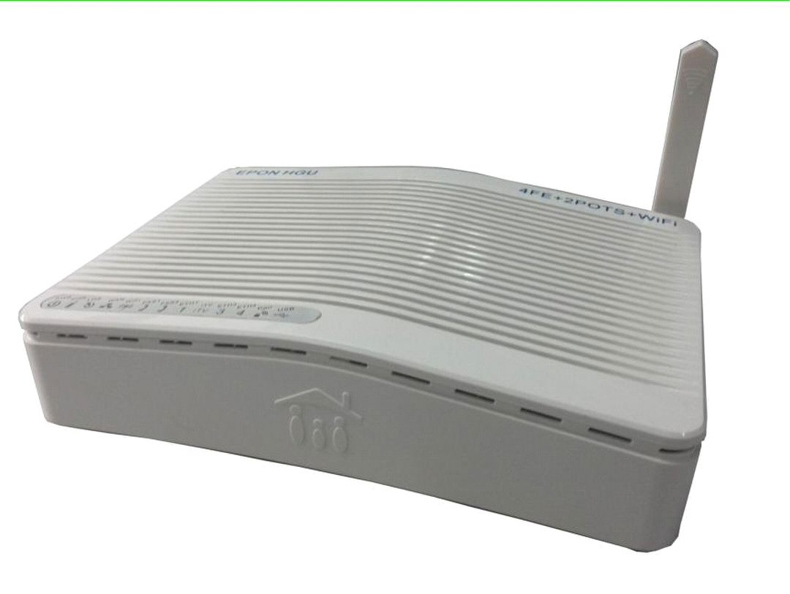
ONT-4GE-2VWX GPON ONT Manual

