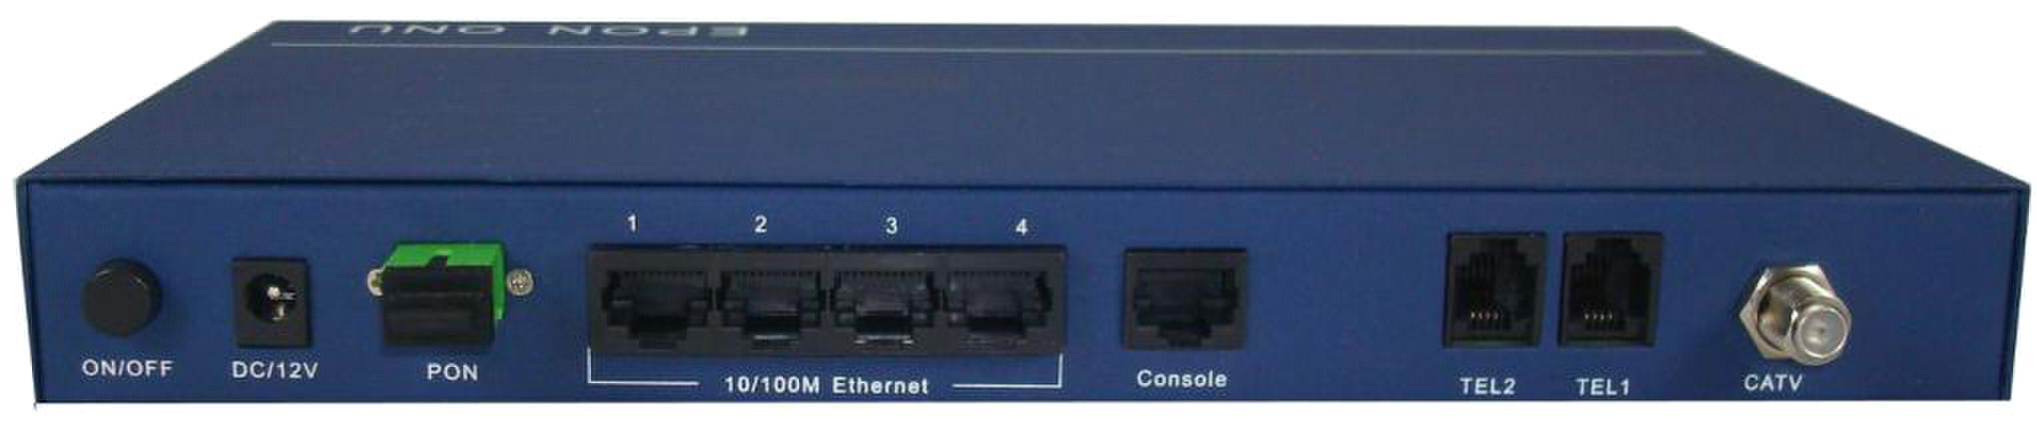
ONU-4FE-2VRF

Key characters

★Completely comply to IEEE 802.3-2005 single optical fiber to provide data, IPTV, audio, and analog CATV ，

realize "triple-play" application。

★Highest data rate PON：symmetrical downstream and upstream 1Gb/s, VoIP audio and IP video service

★Support PNP function based on automatic-detection and figuration

★Advanced QoS function based on SLA

★Support remote management capabilities with expand QAM functions

★Expand L2 function: IGMP, VLAN Rate Limiting and MAC address management

★Integrated VoIP，support MGCP、SIP and H.323

Product introduction

ONU-4FE-2VRF is a high cost performance ONU terminal device used for EGPON. It is designed for domestic and

SOHO consumer, providing Gigabit rate broadband connection for user gateway and/or PC. ONU-4FE-2VRF

provides 4 10/100 base-T Ethernet accesses with powerful L2 function for data and IPTV video service; at the

same time, it provides 2 VoIP ports for audio service and 1 RF port for CATV. It truly realized the application of

“three-in-one network”.
Module function

L2 switching function

■ IEEE 802.1q VLAN

■ MAC management

■ IGMP Snooping

■ IEEE 802.1d STP

■ Rate Limiting

Phonetic function

■ 2 FXS（RJ-11）VoIP

■ VoIP protocols：MGCP，SIP

■ FAX：T38

RF specification

■ Connector：75W，F type（CATV connection）

■ Output level（each channel）：> 15dBmV, with

level tilted up 2.5dB

■ Bandwidth：47MHz ~ 870MHz

■ Drive capability：4 TV

■ CSO: >55dB

■ STB: >55dB

■ CNR level：

1 ） QAM 64, 40 channel: optical power input

30dB@-10dBm

2 ） QAM 256, 40 channel: optical power input

34dB@-10dBm

3 ） Typical 50 analog channel: optical power input

45dB@-10dBm

Optical specification

■ Optical fiber：standard single mode optical fiber

■ Connector：SC/APC

■ Max shunt ratio：32

■ Data rate：1Gbps symmetrical downstream and

upstream

■ Optical power loss budget： 29dB

■ Optical wavelength range: upstream 1310nm

downstream 1490nm

■Video receiver sensitivity:

9dBm~ +2dBm@1550nm
Technical Specification

Hardware index

Physical specification

■ Size：226mm（H）× 152mm（W）× 38 mm（D）

■ Weight：536g

Front connector

■ LED： Power light、 Alarm light、 LAN1 ~ LAN4 link

statutes light and GEPON link statutes light

Rear connector

■ 1 power connect port

■ 1 SC connector for GEPON

■ 4 internet access for RJ-45 10/100M Ethernet

■ 2 audio access for RJ-11 VoIP

■ 1 connector for RF

The power indicate

■ AC/DC power adapter ： 100 ~ 240V AC input

12V DC output

■ Max. power consumption:18W， Average power

consumption: 12W

Operating environmental requirements

■ Temperature：0 ~ 40 °C

■ Humidity：5% ~ 90%

Store environmental requirements

■ Temperature：-40 ~ 75 °C

■ Humidity：Max.75%

Certification

■ VCCI，CE，CCC，UL and FCC 15B

PON standard

■ IEEE 802.3-2005

User authentification

■ IEEE 802.1x

QoS

■ IEEE 802.1p

■ IPv4 TOS priority

■ Differsrv

Supervisor mode

■ Web server，support the remote upgrade and download

from the EMS of remote OLT.

■ Optical power output: @1310nm ： -1dBm ~

+3dBm

■ Receiver sensitivity: @1490nm：<-26dBm

■ Receiver saturation power: @1490nm： -3dBm

■ Return loss（S11）： >35dB

隔离度：

