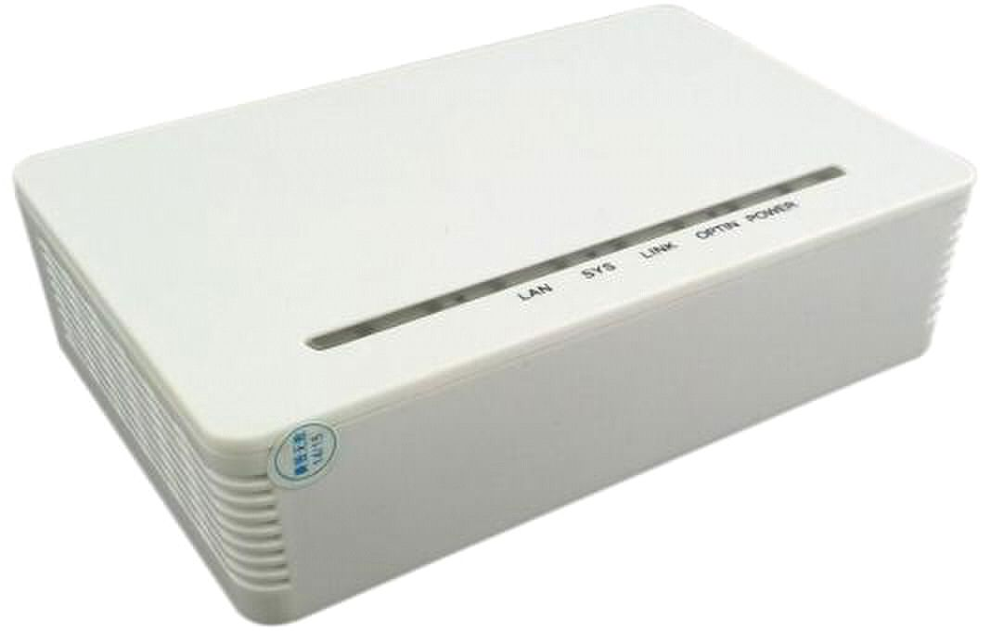
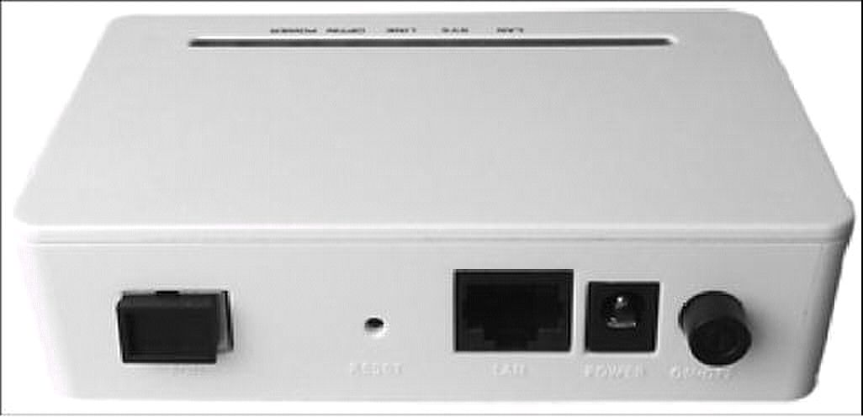
Support port-based rate limitation and bandwidth control;

In compliant with IEEE802.3ah Standard

Up to 20KM transmission Distance

Support data encryption, group broadcasting, port V-lan separation RSTP,etc.

Support Dynamic Bandwidth Allocation (DBA)

Support ONU auto-discovery/Link detection/remote upgrade of software;

Support VLAN division and user separation to avoid broadcast storm;

Support power-off alarm function ,easy for link problem detection

Support broadcasting storm resistance function
ONU-1FE/1GE GEPON ONU Manual

ONU-1FE 1FE/1GE GEPON ONU

(1GE/1GE ETH Port)

Brief Views

GEPON ONU-1FE/ONU-1GE is designed mainly for FTTH use and FTTO use as well. GEPON ONU-1FE/ONU-1GE

support 1000Base-PX10/PX20 standard with 1:64/1:32 maximum optical splitting ratio and 10/20km distance,

and provide 1uplink GE PON port.

ONU ONU-1FE/ONU-1GE together with OLT could realize flexible network structure and maintenance and provide

total FTTx solutions.

ONU ONU-1FE/ONU-1GE adopts single fiber WDM technology with down-link wavelength 1490nm and up-link

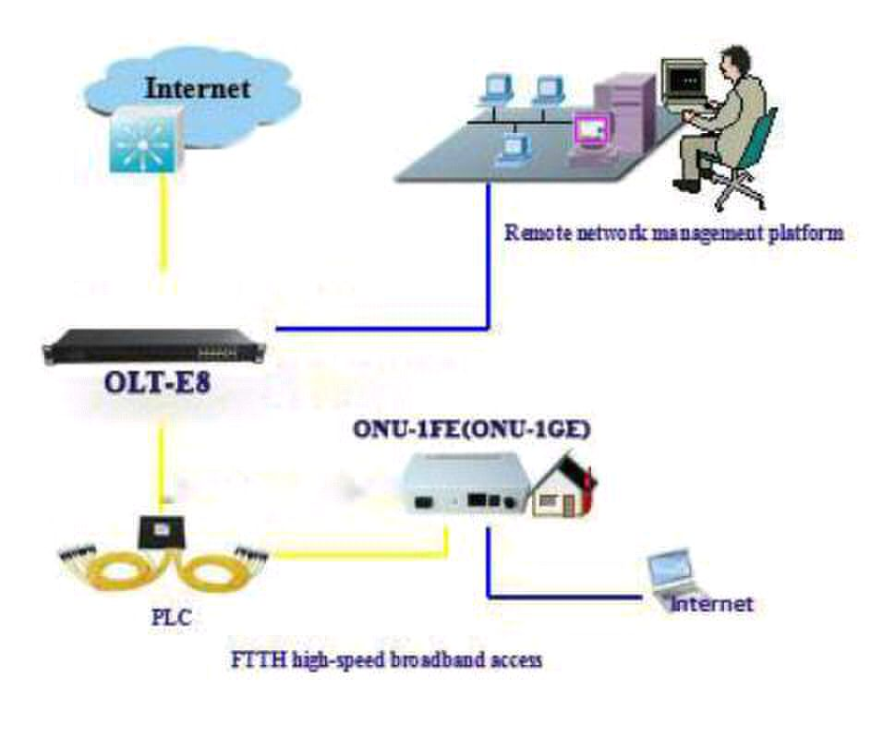
wavelength 1310nm .It only needs one-core fiber to transmit data service.

ONU ONU-1FE has 1 PON port and one 10/100BASE-T ports.

ONU ONU-1GE has 1 PON port and one 10/100/1000BASE-T ports

Functional Feature

■

■

■

■

■

■

■

■

■
Support ACL and SNMP to configure data packet filter flexibly

Specialized design for system breakdown prevention to maintain stable system
ONU-1FE/1GE GEPON ONU Manual

■

■

Specification

Item |  | Parameter
Interface | PON Interface | 1 GEPON optical interface
 |  | Meet 1000BASE-PX20 standard
 |  | Symmetric1.25Gbpsupstream/downstream
 |  | SC single-modfiber
 |  | split ratio:1:64
 |  | Transmission distance 20KM2
 | User Ethernet | 1*10/100Mauto-negotiation (ONU-1FE)
 |  | 1*10/100/1000Mauto-negotiation (ONU-1GE)
 |  | Full/half duplex mode
 | Interface | RJ45 connector
 |  | Auto MDI/MDI-X
 |  | 100m distance
 | Power Interface | 12V DC Power supply
 |  | An external 12V 0.5A AC/DC power supply adapter
Performance | PON | Wavelength: Tx 1310nm, Rx1490nm
 |  | TxOptical Power: -1～4dBm
 |  | Rx Sensitivity: -24dBm
 | Optical
 |  | Saturation Optical Power: -3dBm
 | Parameter
 |  | Connector Type: SC
 |  | Optical Fiber: 9/125 |  | ɥ | m single-mode fiber
 | Data Transmission | PON | Throughput: | Downstream |  | 950Mbps; | Upstream
 |  | 930Mbps
 |  | Ethernet: 100Mbps (ONU-1FE,ONU-4FEC);
Parameters | Parameter | 1000Mbps(ONU-GFE)
 |  | Packet Loss Ratio:<1*10E-12
 |  | latency: <1.5ms
 | Business | Layer 2 wire speed switching
 |  | Support VLAN TAG/UNTAG，VLAN conversion
 |  | Support Port-based speed limitation
 | Capability | Support Priority classification
 |  | Support storm control of broadcast
 |  | Support RSTP
Network | Management | Support IEEE802.3 QAM, ONU can be remotely managed
 |  | by OLT
 | Mode | Support Remote management through SNMP and Telnet
 |  | Local management
Management
 | Management | Status | monitor, | Configuration |  | management, |  | Alarm
 |  | management,
 | Function
 |  | Log management
PON+EOC

IP Camera
、 、

、 、 、
Typical Solution FTTH FTTB

Typical Business INTERNET IPTV VOD
ONU-1FE/1GE GEPON ONU Manual

Indicator | LED Indicator | PWR: Power up or down
 |  | SYS: System instructions
 |  | OPTIN: Optical Link Status
 |  | LINK：ONU Registered
 |  | LAN: Link Status of Ethernet Interface
Physical Features | Shell | Plastic casing
 | Power | External 12V 0.5A AC/DC power supply adapter
 |  | Power consumption: < 3.8W
 | Physical | Item Dimension：160mm(L) x 120mm(W) x 30mm (H)
 | Specifications | Item weight：0.2kg
 | Environmental | Operating temperature: | 0 to 50 ºC
 |  | Storage temperature: -40 to 85 ºC
 | Specifications | Operating humidity: 10% to 90% (Non-condensing)
 |  | Storage humidity: 5% to 95% (Non-condensing)

Application

 ：

 ：

Figure: ONU-1FE/ONU-1GE Application Diagram

