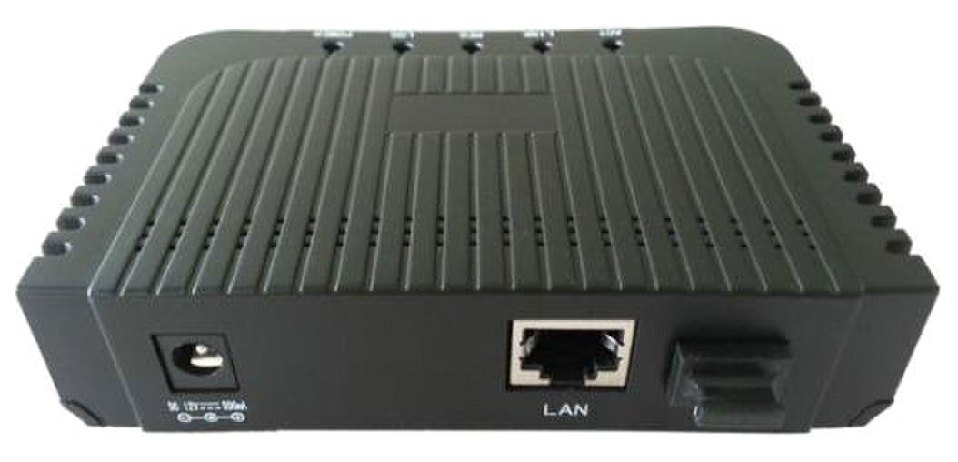
Plug and play, integrated auto-detecting, auto-configuration, and auto firmware upgrade,

Integrated OMCI/TR069 remote configuration and maintenance function.

Support rich QinQ VLAN function and IGMP Snooping multicast feature.

Functions like transceiver diagnostic monitoring, transmitter disable, etc.

Built-in bridging or router mode.

Fully compatibility with OLT based on Broadcom/Broadlight.
ONT-1GEX GPON ONT Manual

ONT-1GEX 1GE GPON ONT

Introduction

ONT-1GEX is a low density GPON ONT designed for fulfilling FTTH request of telecom

operators, internet access of SOHO people and renovation request of GPON+EOC infrastructure

of cable TV operators. This product is based on the stable and mature Gigabit GPON technology,

which has high performance/price ratio. Its GPON MAC chip is the newest generation SOC -

BCM6838 from world famous xPON IC vendor - Broadcom. It is highly reliable and easy to

maintain, with guaranteed QoS. And it is fully compliant to technical regulations such as

ITU~T984.X and technical requirement of GPON Equipment (V1.2 and above version) from China

Telecom.

ONT-1GEX

Special features

●

etc.

●

●

●

●

●

Technical parameter

Technical items | Descriptions
Upstream PON | 1 GPON interface, SC single-mode/single-fibre, Upstream 1.244Gbps,
Interface | Downstream 2.488Gbps.
GPON MAC | BCM6838 SOC from Broadcom.
Wavelength | Tx 1310nm, Rx 1490nm.
Optical interface | SC/PC connector.
Downstream LAN | 1x 10/100/1000Mbps auto adaptive Ethernet interface, Full Duplex/Half
interface | Duplex, RJ45 connector.

Page 1
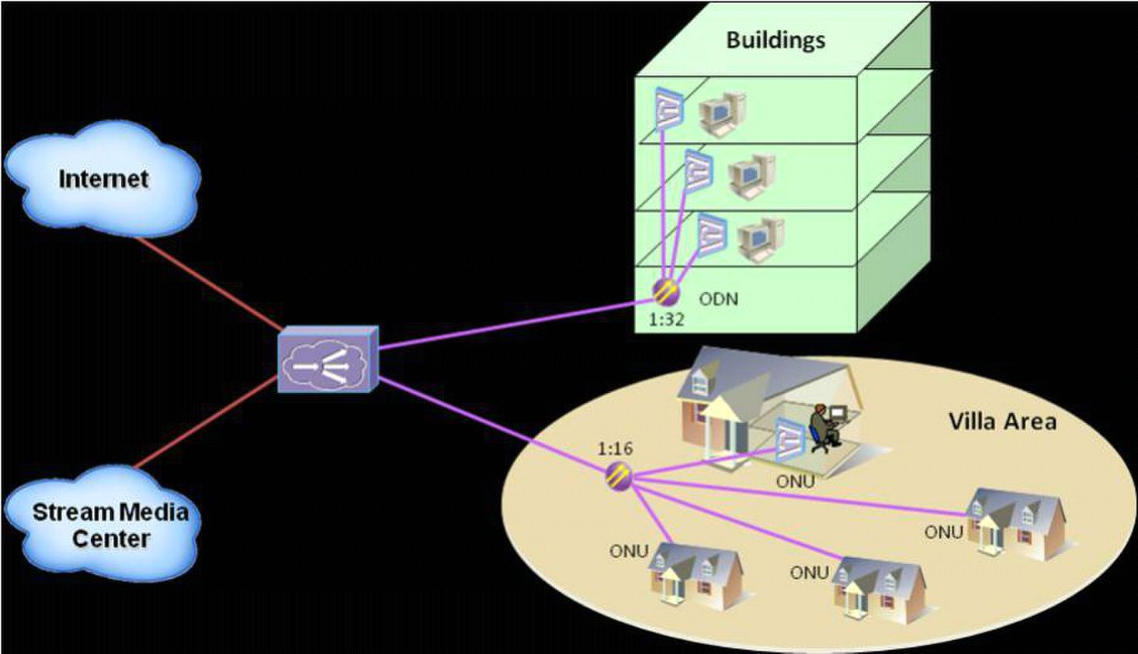
ONT-1GEX GPON ONT Manual

Indicators |  | 5 indicators, for status of power, Los status of PON port, Register status of
 |  | PON port, Link status of Giga-Ethernet port, Active status of Giga-Ethernet
 |  | port.
DC power supply |  | +12V@0.5A, external AC/DC power adaptor
Power |  | ≤5W
consumption
Operating |  | Operating temp: ~5 ~ +55 |  |  | ℃ |  | , operating humidity:10~90% (non-condensed)
condition
Storing condition |  | Storing temp: ~30 ~ +60 |  | ℃ |  | , storing humidity:10~90% (non-condensed)
Device Dimension |  | 115mm*75mm*28mm (length*width*height)
CANTON |  | Internal Canton: 20.5mm*16mm*5.5mm
 |  | Package: 590mm*410mm*325mm
Dimension
 |  | 40PCS/CTN
Net weight |  | 0.24Kg
Application ch | rt
Ordering infor | ation
Product model | GE |  | Work temperature |  |  |  |  | Product Form
ONT-1GEX | 1 |  | ~5 ~ +55℃ |  |  |  |  | Plastic casing

Page 2

