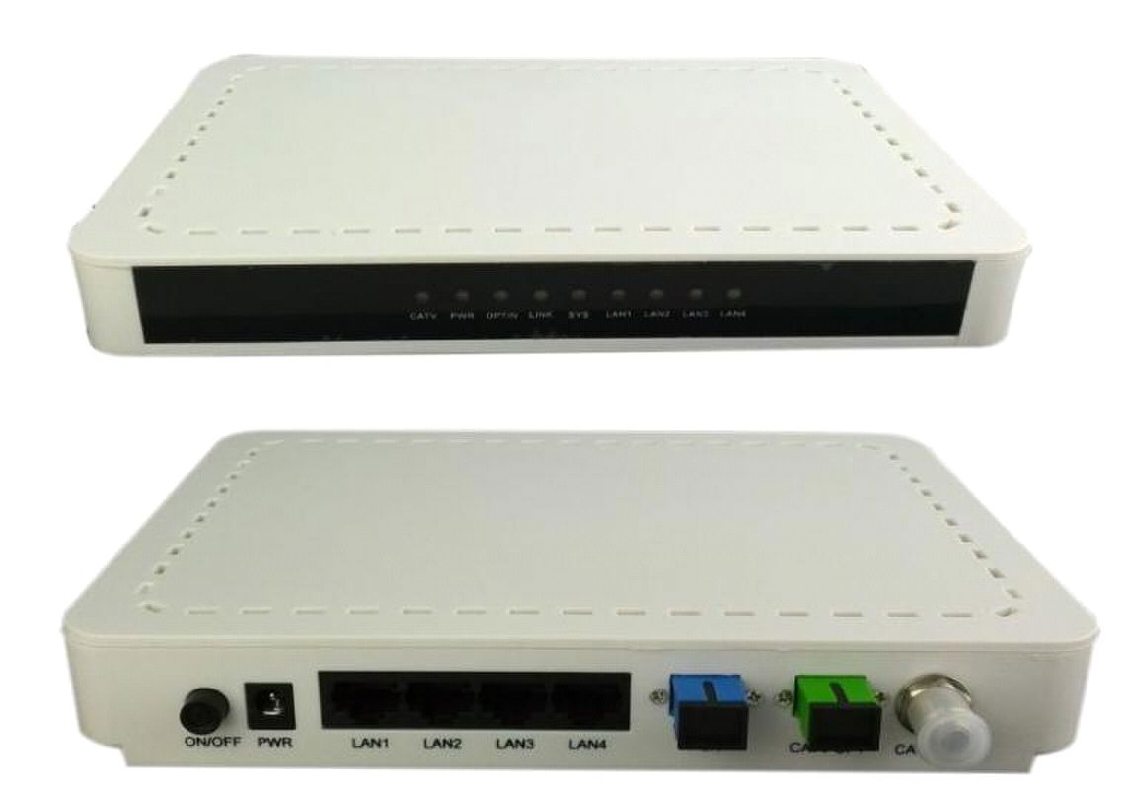
ONU-4FE-DRF GEPON ONU Manual

ONU-4FE-DRF GEPON ONU

(4FE+1CATV With Dual Fiber)

Brief Introduction

The ONU is designed mainly for FTTH use and FTTO use as well. It support

1000Base-PX10/PX20 standard with 1:64/1:32 maximum optical splitting ratio and 10/20km

distance, and provide 1uplink GE PON port.

It work together with OLT could realize flexible network structure and maintenance and

provide total FTTx solutions.

It built in CATV Receiver to realize the analog or DVB TV signals transmission.

It adopts single fiber WDM technology with downlink wavelength 1490nm, uplink

wavelength 1310nm .It only needs one-core fiber to transmit data service. It also have a HFC

optical port, received the CATV optical signals and convert into electric CATV signals.

ONU-4FE-DRF has 1 PON port , 1 HFC optical port, four10/100BASE-T ports and one CATV

output.

- 1 -
In compliant with IEEE802.3ah Standard and CTC2.1

Up to 20KM transmission Distance

Support VLAN and IGMP

Support port isolation between different ports

Integrated OAM remote configuration and maintenance function

Plug and play, integrated auto detecting, auto configuration, and auto firmware

EMS network management based on SNMP ,convenient for maintenance

Full speed non-blocking switching.

Support QinQ VLAN, 1:1 VLAN, VLAN reusing, VLAN trunk, etc.

Integrated port monitoring, port mirroring, port rate limiting, port SLA, etc.

Support auto polarity detection of Ethernet ports (AUTO MDIX).

Integrated IEEE802.1p QoS with four level priority queues.

Support IPv4 IGMP snooping and IPv6 MLD snooping.

Turn on/off RF output remotely

Wavelength 1550 +/- 10nm

Optical return loss >45dB

Input opticl power -8dBm +2dBm

RF frenquency 47MHz~875MHz

RF output lever 75 80dBuV

CNR >46dB CSO: >58dBc CTB: >58dBc

RF output return loss >14dB

RF impedance 75Ohm

AGC function optional
ONU-4FE-DRF GEPON ONU Manual

Functional Feature

■

■

■

■

■

■

upgrade technology

■

■

■

■

■

■

■

CATV Service Functions

■

■ ：

■ ：

■ ： ～

■ ：

■ ： ～

■ ： ， ，

■ ：

■ ：

■

Specification

Item |  | Parameter
Interface | Uplink Interface
 |  | PON Interface:
 |  | 1 GEPON optical interface
 |  | Meet 1000BASE-PX20 standard
 |  | Symmetric 1.25Gbps upstream/downstream
 |  | SC single-mode fiber
 |  | split ratio: 1:64
 |  | Transmission distance 20KM @ split ratio<1:32

- 2 -
ONU-4FE-DRF GEPON ONU Manual

 |  |  |  | CATV Interface:
 |  |  |  | 1 HFC Optical input
 |  |  |  | SC/APC
 |  |  | User Interface | 4*10/100Mauto-negotiation
 |  |  |  | Full/half duplex mode
 |  |  |  | RJ45 connector
 |  |  |  | Auto MDI/MDI-X
 |  |  |  | 100m distance
 |  |  |  | 1 RF output
 |  |  |  | Female F-Type Connector
 |  |  | Power Interface | 12V DC Power supply
 |  |  |  | An external 12V 0.5A AC/DC power supplyadapter
Performance |  |  | PON | Wavelength: Tx 1310nm, Rx1490nm
 |  |  |  | TxOptical Power: -1～4dBm
 |  |  |  | Rx Sensitivity: -24dBm
 |  |  | Optical
 |  |  |  | Saturation Optical Power: -3dBm
 |  |  | Parameter
 |  |  |  | Connector Type: SC
 |  |  |  | Optical Fiber: 9/125 |  |  |  | ɥ | m single-mode fiber
 |  |  | Data Transmission | PON Throughput: Downstream 950Mbps; Upstream 930Mbps
 |  |  |  | Ethernet: 100Mbps
Parameters |  |  | Parameter | Packet Loss Ratio: <1*10E-12
 |  |  |  | latency: <1.5ms
 |  |  | Business | Layer 2 wire speed switching
 |  |  |  | Support VLAN TAG/UNTAG，VLAN conversion
 |  |  |  | Support Port-based speed limitation
 |  |  | Capability | Support Priority classification
 |  |  |  | Support storm control of broadcast
 |  |  |  | Support RSTP
Network | Management |  |  | Support IEEE802.3 QAM, ONU can be remotely managed by
 |  |  |  | OLT
 | Mode |  |  | Support Remote management through SNMP and Telnet
Management |  |  |  | Local management
 |  |  | Management | Status | monitor, |  | Configuration |  |  | management, | Alarm
 |  |  |  | management,
 |  |  | Function
 |  |  |  | Log management
Indicator |  |  | LED Indicator | PWR, SYS,PON, LAN1~LAN4, CATV
Shell |  |  |  | Plastic casing
Physical Features |  |  | Power | External 12V 0.5A AC/DC power supply adapter
 |  |  |  | Power consumption: < 3W
 |  |  | Dimension and Weight | Item Dimension |  | ： | 200mm(L) x 140mm(W) x 28mm (H)

- 3 -
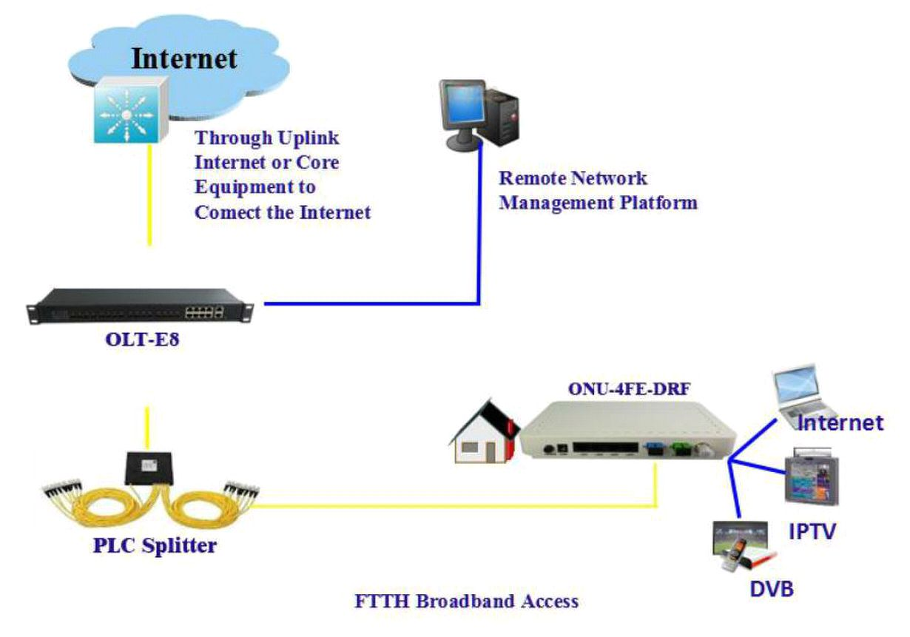
PON+EOC

VOD IP Camera
、 、

、 、 、 、
Typical Solution FTTH FTTB

Typical Business INTERNET CATV IPTV
ONU-4FE-DRF GEPON ONU Manual

 |  |  | Item weight | ：0.35kg
 |  | Environmental | Operating temperature: 0 to 50ºC
 |  |  | Storage temperature: -40 to 85ºC
 |  | Specifications | Operating humidity: 10% to 90%(Non-condensing)
 |  |  | Storage humidity: 5% to 95%(Non-condensing)

Application

 ：

 ：

Network Construction

●Figure: ONU-4FE-DRF Application Diagram

- 4 -

