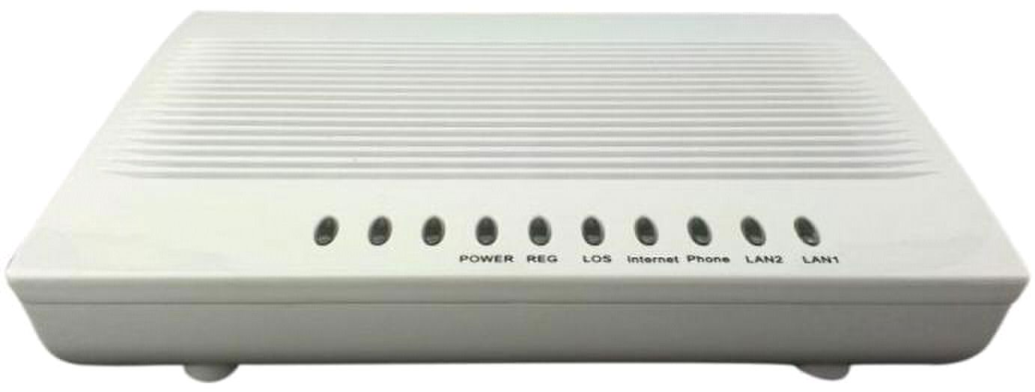
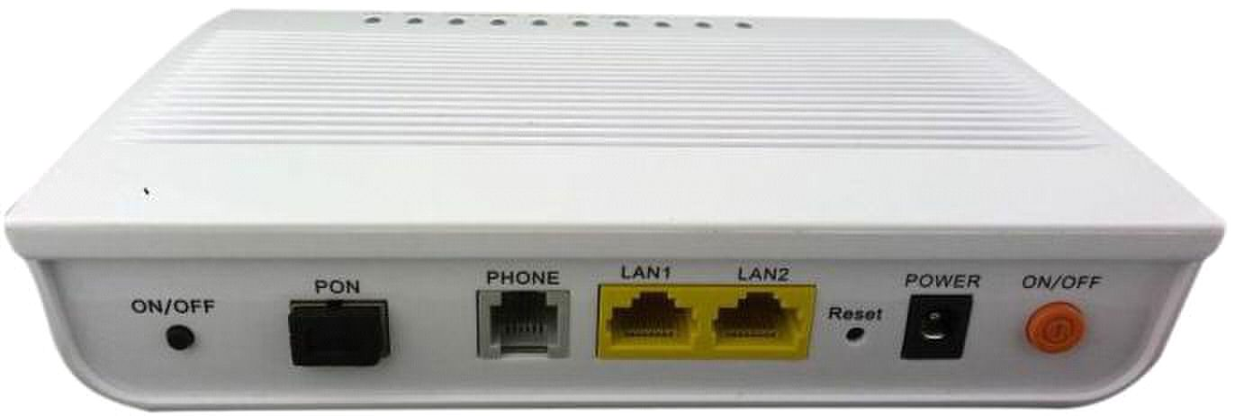
Support VOIP

Support G.711 a/u law, G.729a CODEC algorithm

Support G.168echo cancellation

Support DTMF

System Ring Cadence:4 Cadences

Support Calling Number Management

Support call forward, call waiting
ONU-2FE-1V EPON HGU Manual

ONU-2FE-1V EPON HGU

(2FE+1POTS)

Product Overview

The ONU is designed for FTTH application. It can provide one 10/100M and one POTS to the user,

convenience for Internet and Voice service.

Function Features

POTS Service Function

■

■

■

■ Support VAD、CNG

■

■

■

■
WRR queue scheduling

step 8K
、 、 ＋

： ，
Support T.30FAX FAX transparent transmission

Support T.38 FAX relay

Support SIP SDP RTP/RTCP

Support 802.1p, Up to 8 CoS queues, SP WRR SP

Support Auto-negotiation

Support 802.1Q Tag VLAN

Support broadcast-storm control

Support the speed limited from8k to 100M

Support flows control

Support IGMP snooping

Support WEB security management based HTTP

Support WEB access from local and OLT side

Support Ethernet interface configuration and query

Support configuring the FE interface to negotiate/rate/duplex

Support the flow control, bandwidth, priority, VLAN ID of interface

Support ONU Remote management
ONU-2FE-1V EPON HGU Manual

■ ：

■

■ 、 、

DATA Service Function

■

■

■

■

■

■

■

O&M Function

■

■

■

■ Support disable FE interface of ONU；

■

■

■

Specification

Item | Specifications
Optical Interface
Number of ONU | 32 ONU@ 20Km
Transmission Rate |  Uplink：1.25 Gbps
 |  Downlink：1.25 Gbps
Connector | SC/PC
Optical Specification |  Up
 | – | Wavelength | ： | 1490nm±10nm
 | – | Receive Sensitivity |  |  | ： | -24dBm
 | – | Receive Saturation Power |  |  |  |  | ： | -3dBm
 |  Down
 | – | Wavelength | ： | 1310nm±50nm

ONU-2FE-1V EPON HGU Manual

Item | Specifications
 | – | Output Power (Min) |  | ： | -1dBm
 | – | Max Optical Spectral Width |  |  |  | （ | -20 dB | ）： | 3nm
Fiber | G.652 Single Mode Fiber
Ethernet Interface
Standards |  IEEE802.3
 |  IEEE802.3au
 |  IEEE802.3x
LAN |  2*10/100BASE-T
 |  MDI/MDIX
 |  Auto-negotiation
Ports | 2 FE
Connector Type | RJ-45
Impedance | 100Ohm
Auto-negotiation |  IEEE 802.3
 |  10/100BASE-T
 |  Full Duplex / Half-duplex
 |  MDI/MDIX
VLAN | IEEE802.1q
Transmission Distance | 100m Max
POTS Interface
Ports | 1
Connector Type | RJ-11
Transmission Distance | Max 1km
Number of Phone | 3 REN
Ringing Voltage | Vrms>50V
Environment Requirement
Operating Temperature | 0ºC~40ºC
Storage Temperature | -20ºC~70ºC
Operating Humidity | 10%~90%，non-condensed
Storage Humidity | 5%~95%，non-condensed
Power Supply | DC 12V 1A
Regulatory Compliance
Regulatory Compliance | 3C
Regulatory Compliance | RoHS
Physical Specification
Dimension | LxWxH | ： | 166.6mm*122.4mm*31.8mm (L*W*H)
Weight | ＜300g

