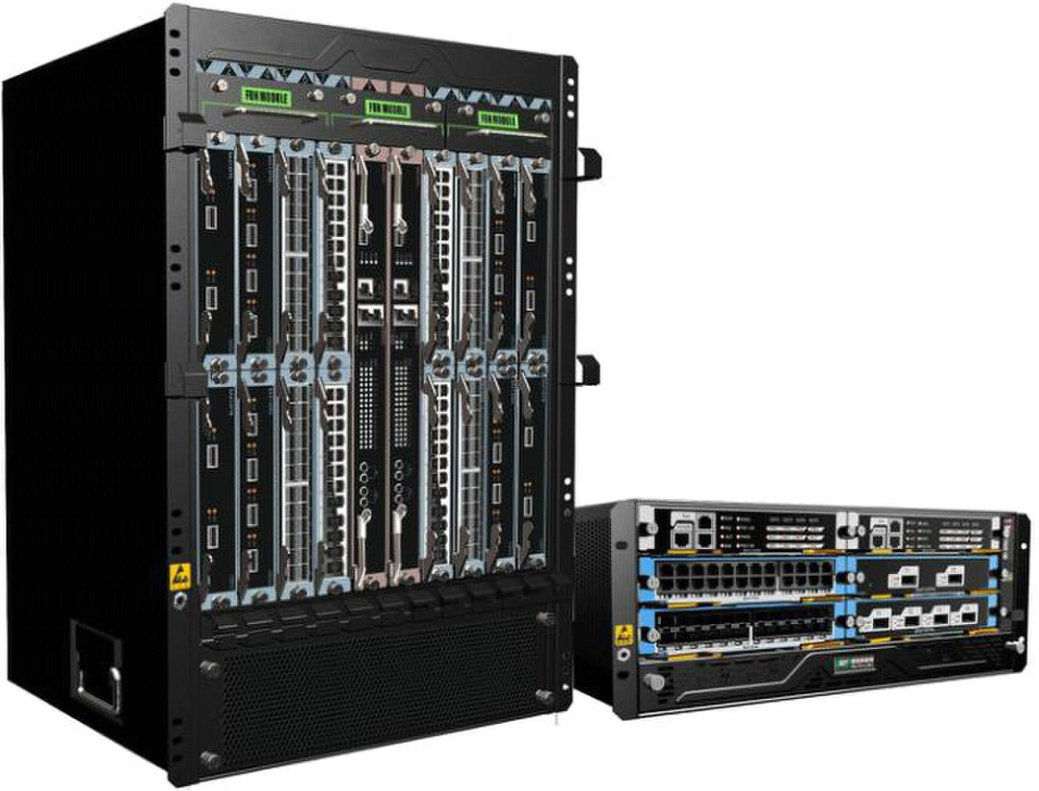
SG8800 Series High-density Terabit Core Switching OLT

Data Sheet

SG8800 series are designed for high-density access switching integrated platform which

combine multi-service and high-density 10G xPON OLT requirement, they are deployed

for high-density xPON OLT as carrier broadband access network.SG8800 series have the

unique half-size slot service cards for the highest density EPON/GPON/10GE/10GEPON

port and terabit switching net can provide the ability of 40/100G future upgrade switching

and smooth upgrade access platform. SG8800 series have the first innovation processing

architecture with fully distributed based on 64-bit multi-core processors and high

performance AISC. They can provide IPv4/IPv6 wire-speed transferring capacity and be

widely used on the IP MANs of carriers, WANs and MANs of enterprises, egress, core

layer, and convergence layer of enterprise

WirelessVisionltd Co., Ltd All Rights Reserved - 1 -
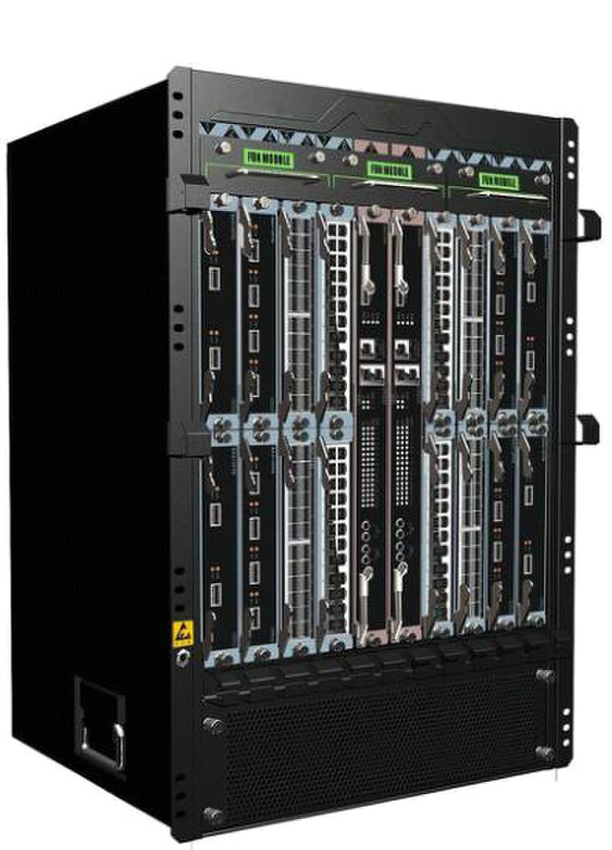
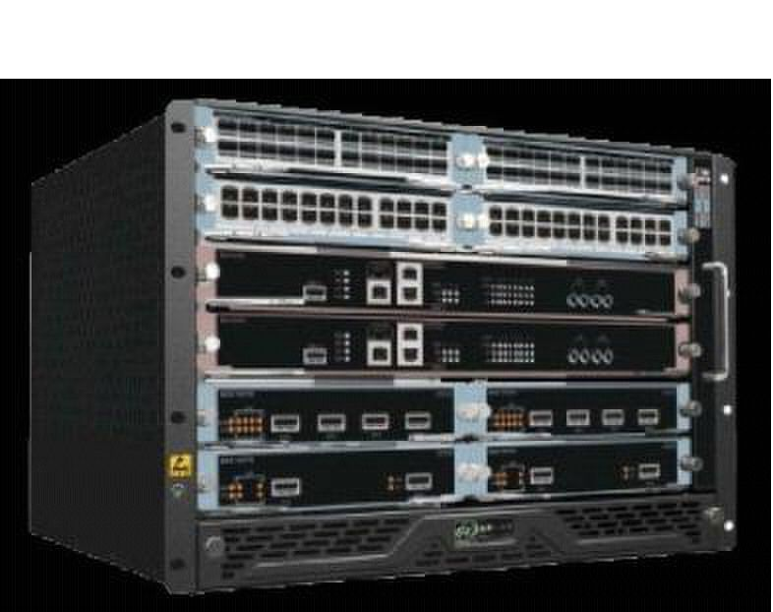
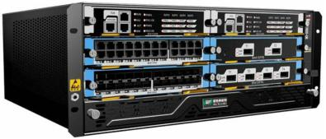
□ 1+1 master control redundancy,1+1power supply

redundancy

□ 7U compact design, half-size serve slots

□ IPv4/IPv6 and MPLS hardware line speed
□ 4U compact design, half-size serve slots

SG8800-4

□ Hot plug fan chassis, intelligent speed and

temperature control

□ 6slots，2 main control cards,4 line cards

□ Maximum support 32*GPON and 32*GE

□ Support EPON/10GEPON mixed insertion for

future new cards

□ 1.6Tbps widely backplane capacity and smooth

upgrade to 40G/100G

□ IPv4/IPv6 and MPLS hardware line speed

forwarding

□ The whole power consumption less than 350W

SG8800-8

□ 1+1 master control redundancy,1+1power supply

redundancy

□ Hot plug fan chassis, intelligent speed and

temperature control

□ 10slots，2 main control cards,8 line cards

□ Maximum support 64*EPON and 64*GE

□ Support EPON/10GEPON mixed insertion for future

new cards

□ 3.2Tbps widely backplane capacity and smooth

upgrade to 40G/100G

SG8800-16

forwarding

□ 15U compact design, half-size serve slots

□ 1+1 master control redundancy,2+2power supply

redundancy

□ Hot plug fan chassis, intelligent speed and

temperature control

□ 18slots，2 main control cards,16 line cards

□ Maximum support 128*EPON and 128*GE

□ Support EPON/10GEPON mixed insertion for future

new cards

□ 6.4Tbps widely backplane capacity and smooth

upgrade to 40G/100G

□ IPv4/IPv6 and MPLS hardware line speed

forwarding

□ The whole power consumption less than1200W

WirelessVisionltd Co., Ltd All Rights Reserved - 2 -
Product Specification:

Item |  | SG8800-4 |  | SG8800-8 | SG8800-16
Back-plane Capacity |  | >1.6Tbps |  | >3.2Tbps | >6.4Tbps
Switching Capacity |  | 960Gbps |  | 1.6Tbps | 3.2Tbps
Throughput |  | 720Mpps |  | 1440Mpps | 2860Mpps
(IPv4/IPv6)
Number of slots |  | 6 |  | 10 | 18
Number of service |  | 4 |  | 8 | 16
board slots
Service | EPON | 32*EPON,24*GE |  | 64*EPON,48*GE | 128*EPON,96*GE
 | GPON | 32*GPON,32*GE |  | 64*GPON,64*GE | 128*GPON,128*GE
Port
 | Switch | 96*GE,32*10GE |  | 192*GE,64*10GE | 384*GE,128*10GE
Redundancy Design |  | 1+1 power redundancy |  | 1+1 power redundancy | 2+2 power redundancy
 |  | 1+1 main control |  | 1+1 main control | 1+1 main control
 |  | redundancy |  | redundancy | redundancy
Power Supply |  | AC: 90～260V，50～ | 60 | z;
 |  | DC: -36V～-72V;
Power Consumption |  | ≤300W |  | ≤680W | ≤1200W
Outline Dimensions |  | 442mm×176mm×420m |  | 442mm×310mm×420mm | 442mm×664mm×420mm
(mm) (W*D*H) |  | m
Weight (In Maximum |  | ≤15kg |  | ≤25kg | ≤45kg
Configuration)
Environmental |  | Working temperature: 0°C～40°C
 |  | Storage temperature: -40°C～70°C
Parameter
 |  | Relative humidity: 10%～90%，no condensing

Attributes |  | SG8800 series
PON Features | EPON | IEEE 802.3ah EPON
 |  | China telecom/Unicom | GPON standard
 |  | 20Km for single fibber
 |  | Access 64 terminals for single fibber PON
 |  | Uplink and downlink triple churning encrypted function
 |  | ONU terminal legitimacy certification, report illegal ONU registration
 |  | DBA algorithm
 |  | Standard OAM and extended OAM
 |  | ONU batch software upgrade, fixed time upgrade, real time upgrade
 |  | PON transmit and inspect receiving optical power

WirelessVisionltd Co., Ltd All Rights Reserved - 3 -
 | GPON | Satisfy ITU -T standard
 |  | TR-101 compliant solution for FTTx OLT applications
 |  | High splitter rate, each PON port supports 32*ONU, 96*T-CONT
 |  | Maximum transmission distance of 20KM
 |  | Support uplink FEC, downlink FEC(Forward Error Correction)
 |  | ONU identifier authentication: SN /SN+PASSWD
 |  | Bandwidth allocation mechanism
 |  | 5 types of T-CONT bandwidth
 |  | Static Bandwidth Allocation
 |  | Dynamic Bandwidth Allocation
 |  | GPON feature parameter
 |  | 4096 port-IDs per GPON MAC (Downstream and Upstream)
 |  | 1024 Alloc -IDs per GPON MAC (Upstream )
L2 Features | MAC | MAC Black Hole
 |  | Port MAC Limit
 | VLAN | 4K VLAN entries
 |  | Port-based/MAC-based/IP subnet-based VLAN
 |  | Port-based QinQ and Selective QinQ (StackVLAN)
 |  | VLAN Swap and VLAN Remark and VLAN Translate
 |  | GVRP
 |  | Based on ONU service flow VLAN add, delete, replace
 | Spannin | IEEE 802.1D Spanning Tree Protocol (STP)
 |  | IEEE 802.1w Rapid Spanning Tree Protocol (RSTP)
 | g tree
 | protocol | IEEE 802.1s Multiple Spanning Tree Protocol instances (MSTP)
 | Port | Bi-directional bandwidth control
 |  | Static link aggregation and LACP(Link Aggregation Control Protocol)
 |  | Port mirroring and traffic mirroring
Security | User | Anti-ARP-spoofing
 |  | Anti-ARP-flooding
 |  | IP Source Guard create IP+VLAN+MAC+Port binding
 |  | Port Isolation
 |  | MAC address binds to port and port MAC address filtration
 | security
 |  | IEEE 802.1x and AAA/Radius authentication
 |  | TACACS+ authentification
 |  | dhcp anti-attack flood attack automatic suppression
Features
 |  | ONU isolation control
 | Device | Anti-DOS attack(such as ARP，Synflood, Smurf, ICMP attack), ARP detection,
 |  | worm and Msblaster worm attack
 |  | SSHv2 Secure Shell
 | security | SNMP v3 encrypted management
 |  | Security IP login through Telnet
 |  | Hierarchical management and password protection of users

WirelessVisionltd Co., Ltd All Rights Reserved - 4 -
 | Network | User-based MAC and ARP traffic examination
 |  | Restrict ARP traffic of each user and force-out user with abnormal ARP traffic
 |  | Dynamic ARP table-based binding
 |  | Supports IP+VLAN+MAC+Port binding
 |  | L2 to L7 ACL flow filtration mechanism on the 80 bytes of the head of
 | security | user-defined packet
 |  | Port-based broadcast/multicast suppression and auto-shutdown risk port
 |  | URPF to prevent IP address counterfeit and attack
 |  | DHCP Option82 and PPPoE+ upload user’s physical location
 |  | Plaintext authentication of OSPF, RIPv2 and MD5 cryptograph authentication
IP Routing | IPv4 | ARP Proxy
 |  | DHCP Relay
 |  | DHCP Server
 |  | Static route
 |  | RIPv1/v2
 |  | OSPFv2
 | IPv6 | ICMPv6
 |  | ICMPv6 redirection
 |  | DHCPv6
 |  | ACLv6
 |  | OSPFv3
 |  | RIPng
 |  | Configured Tunnel
 |  | 6to4 tunnel
 |  | IPv6 and IPv4 Tunnels
Service | ACL | Standard and extended ACL
 |  | Time Range ACL
 |  | Packet filter providing filtering based on source/destination MAC address,
 |  | source/destination IP address, port, protocol, VLAN, VLAN range, MAC
 |  | address range, or invalid frame. System supports concurrent identification at
 |  | most 50 service traffic
 |  | Support packet filtration of L2～L7 even deep to 80 bytes of IP packet head
 | QoS | Rate-limit to packet sending/receiving speed of port or self-defined flow and
 |  | provide general flow monitor and two-speed tri-color monitor of self-defined
Features
 |  | flow
 |  | Priority remark to port or self-defined flow and provide 802.1P, DSCP priority
 |  | and Remark
 |  | CAR(Committed Access Rate), Traffic Shaping and flow statistics
 |  | Packet mirror and redirection of interface and self-defined flow
 |  | Super queue scheduler based on port and self-defined flow. Each port/ flow
 |  | supports 8 priority queues and scheduler of SP, WRR and SP+WRR.
 |  | Congestion avoid mechanism，including Tail-Drop and WRED

WirelessVisionltd Co., Ltd All Rights Reserved - 5 -
 | Multicast | IGMPv1/v2/v3
 |  | IGMPv1/v2/v3 Snooping
 |  | IGMP Filter
 |  | MVR and cross VLAN multicast copy
 |  | IGMP Fast leave
 |  | IGMP Proxy
 |  | PIM-SM/PIM-DM/PIM-SSM
 |  | PIM-SMv6、PIM-DMv6、PIM-SSMv6
 |  | MLDv2/MLDv2 Snooping
 | MPLS | NPLS LDP
Reliability | Loop | EAPS and GERP (recover-time <50ms)
 | protectio | Loopback-detection
 | n
 | Link | FlexLink (recover-time <50ms)
 |  | RSTP/MSTP (recover-time <1s)
 | protectio
 |  | LACP (recover-time <10ms)
 | n
 |  | BFD
 | Device | VRRP host backup
 |  | Double fault-tolerant backup of host program and configuration files
 |  | 1+1 main control panel hot backup
 | protectio
 | n | 1+1 power hot backup
 |  | Fan redundancy
Maintenance | Network | Telnet-based statistics
 |  | RFC3176 sFlow
 |  | LLDP
 | maintena
 |  | 802.3ah Ethernet OAM
 | nce
 |  | RFC 3164 BSD syslog Protocol
 |  | Ping and Traceroute
 | Device | Command-line interface（CLI）, Console, Telnet and WEB configuration
 |  | System configuration with SNMPv1/v2/v3
 | manage
 |  | RMON (Remote Monitoring)1/2/3/9 groups of MIB
 | ment
 |  | NTP(Network Time Protocol)

WirelessVisionltd Co., Ltd All Rights Reserved - 6 -

